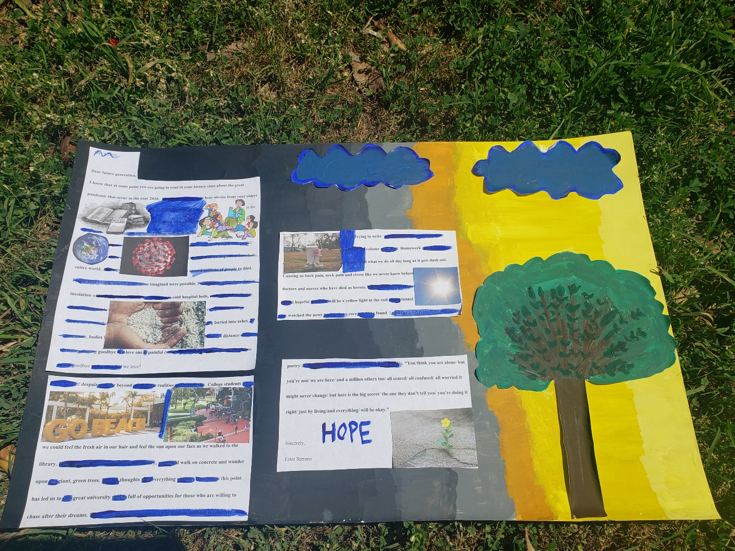
The Original Letter that is Displayed on My Art Work
May 6 2020,

Dear future generation,
I know that at some point you are going to read in your history class about the great pandemic that occur in the year 2020. As well you are going to hear stories from your elders how society was impacted by the famous Covid-19 era. The Covid-19 started in China and in the beginning several theories developed on how the virus unfolded into society such as: the virus coming from bats, people eating bats in China, wet markets, scientist created the virus to study it and it accidently got out of the labs, the virus came from a sercert society of people with power, and so on. Regardless of what you heard the true reality is that the Covid-19 impacted the whole entire world, and sadly in some countries worse than others caused millions of people to died. People have died in ways that we never imagined were possible. For instance, many have died in insolation without any of their loved ones present in cold hospital beds, or alone in their homes. Many of the people that have died did not even get a proper funeral that every human being should have with their loved ones to remember their lives, instead just being buried into ashes. In some cases, bodies have been placed into large trucks as families watched from a distance inside their cars. Saying goodbye to a love one is painful enough and imagine being rejected the chance to say goodbye to the ones that we love?
The level of despair goes far beyond of what our realities use to look like. College students use to be able to go to school and sit in classrooms with our peers and teachers. We didn’t have to deal with internet issues, or delays on Zoom. We use to be able to meet our friends or coworkers for lunch before work or class. If we needed a quiet area to focus on our classwork or homework, we could feel the fresh air in our hair and feel the sun upon our face as we walked to the library. When it would be time to leave the library, we would walk on concrete and wonder upon the giant, green trees. Having thoughts that everything we have done up to this point has led us to this great university that is full of opportunities for those who are willing to chase after their dreams. Now, with all that being taken away from us nothing is concrete.
We sat in our homes in uncomfortable chairs trying to write in our households as our fathers are watching television in the living room with the volume at all blast. Homework use to take us a decent number of hours then and now that is all what we do all day long as it gets dusk out. Causing us back pain, neck pain and stress like we never knew before. Never the less, doctors and nurses who have died as heroes. All I can say is that beyond all this chaos we stayed hopeful that there will be a yellow light at the end of this tunnel. We waited. Patiently as we watched the news hoping that a cure would be found. I read this short poem from Atticus’s poetry during this era that stuck with me and it goes like this, “You think you are alone/ but you’re not/ we are here/ and a million others too/ all scared/ all confused/ all worried it might never change/ but here is the big secret/ the one they don’t tell you/ you’re doing it right/ just by living/and everything/ will be okay.”
Sincerely,
Ester Serrano

