The COVID Chronicles
Jacob Hertz

Fill your paper with the breathings of your heart. —William Wordsworth

It is important to chronicle my life and make my voice heard during this pandemic. The COVID-19 outbreak is a historical event that we are all living through right now. The last time anything like this happened was in 1918 with the Spanish Flu. Everyone’s lives have been affected by the Coronavirus worldwide. The self-quarantine order enacted by the government has been an interesting experience to say the least. Schooling has shifted from face-to-face learning into online learning, and those in the working force who are not considered to be essential must also self-quarantine at home. I have been able to spend a lot more time with my family, and online learning has its perks, but the coronavirus is just something we were not prepared for. The sheer, massive scale this virus is on is extraordinary. All predictions for when it will be over are constantly pushed further and further back in the future. Along with keeping up with the news and social media, online schooling has also been a great way to process and learn about what is going on. In my English class, we have been given plenty of prompts that let us reflect on our situation and analyze our emotions. Those chronicles were great ways for me to either just vent my feelings, or really take a different perspective on the matter. Everyone is going through this pandemic together, but not everyone is going through it the same way. By chronicling what is going on right now in our lives and letting our voices be heard, we can be better prepared for anything like this. Now I will share my chronicles and let my voice be heard.

Our Time in Isolation Together

During this time of social distancing I am trying my best to stay connected through text and social media. Social distancing are the measures taken to physically distance yourself from others to reduce the spread of a formidable virus, like the COVID-19 virus going on right now. My mom and dad are divorced, so I usually spend the weekdays with my mom and the weekends with my dad. With the virus’s immense presence during these times, my mom has made sure that my exposure to the outside world has been greatly reduced. Fortunately, I am still able to go to my dad’s on the weekends. However, whether I’m at my mom’s place or my dad’s, the cabin fever is really starting to set in. My dad always took my brother and me to the local park to get some exercise, but that has been closed down due to the virus. As I’m sure everyone else has experienced, essential supplies, like toilet paper, hand sanitizer, and even some foods, have been scarce due to the wide-spread panic. The daily precautions that we have to make to even go out to do shopping has been severely ramped up. Going anywhere is pretty much a risk unless you have disinfecting products with you. The worst part of all this, in my opinion, is the amount of unemployment that resulted from social distancing. I understand the reasons for doing this, but I am still dependent on my parents, and my mom can not make any money at the moment. Unexpectedly, there are still some positives to come out of social distancing. I am able to spend more time than usual with my family. We are able to do more around the house that we would not have done normally, like clean or cook more. Admittedly, my sleep schedule is messed up from this, but I am still getting at least 8 hours of sleep everyday, even if the time I’m sleeping is a bit unorthodox. I am still able to connect with others through text, Zoom classes, or over social media. My family has a big group text, and we all keep tabs on each other, make sure everyone is doing fine, and lift each other’s spirits. Social Distancing has forced everyone into doing school from home and online now, so I do that through the website Zoom. Itt works exactly how I expected it to, and it does not really hinder my ability to learn that much, so for an emergency alternative to teaching, it is pretty adequate. Over social media is how I mainly stay connected with my friends. My friends and I mainly use Discord to have our conversations, or have a group voice call to play online games together. With everyone on the internet at the same time, I am glad that things have not been terrible in terms of speed and connection. With everything going on, I am glad that things have not gotten any worse for me, my family, or my friends. I hope that this situation that we are in will come to pass sooner rather than later, and I hope that everyone stays safe. I know we can all weather this storm if we all work together.

Empty Spaces

A typically-crowded place that I have dreamed of having all to myself would have to be either the local mall, or a water park on a hot day. I would love to have the mall all to myself, because, as I’m sure you may have guessed by now, I would go on a massive shopping spree. My local mall is the Westfield Mall, and it has plenty of different types of stores that have a lot of the things that I like. GameStop is one of my favorite stores because of the wide selection of games to choose from, along with some other knick knacks that relate to video games as well. I would definitely start my shopping spree there and raid it for all the games I would like to try, or have always wanted. Playing video games is a huge hobby of mine, so to be able to play those games without breaking the bank is a dream come true. I love all types of games, so whether it would be multiplayer games I can play with my friends, or single player games that tell compelling stories through fun and exciting gameplay, I would thoroughly enjoy them all. However, I had to get a little more specific with the water park. To me, it is one thing to have a water park all to yourself, but the conditions have to be right in order to really enjoy your time there. Amusement parks can be visited and enjoyed year-round, but a water park is more seasonal. It is an absolute must for a water park to be visited on a hot day, because that is the main selling point. Being able to simultaneously have fun while getting cooled off is a conditional, but rewarding business tactic. The thing that kills the mood at most water parks is the wait for the lines. The heat hits harder at a water park because you are wearing less clothing than usual, and like I said before, it is visited on hot days in the summer, so the heat is even worse. With the extra people out of the way, the enjoyment automatically goes to the next level. Even though both of these things will be nothing but a fantasy in my mind, it is still fun to imagine the possibility of such dreams ever becoming a reality.

Play it Loud

Music is one of the few things that everyone has in common. Although our tastes in music can differ completely, the concept as a whole is such a universal connection between people. I tend to be pretty picky about what I like to listen to. The main genres of music I listen to are video game music or Japanese/Korean rock or pop. I still listen to some of the big hits like “September” from “Earth, Wind, and Fire”, but I tend to gravitate towards the aforementioned genres more often than not. I play a lot of video games, and a lot of their soundtracks sound really great to me, so listening to them not only makes me just feel better in general, but also lets my mind drift off into my subconscious and imagine the craziest things that would never be possible in this reality. It might not always have lyrics, but that does not take away from any of the enjoyment. I also watch a decent amount of anime (an animated Japanese show, usually an adaptation to the comic book story) which also tends to have pretty good soundtracks that I like to listen to. That music also lets my mind drift, but I also like it because I do not understand it. The foreign vocals are just another instrument for me to appreciate. I am not one to usually care for any lyrics in a song, or what meaning they hold, so these genres fit pretty well within my tastes. Without the lyrics, I am able to pay more attention to the actual instruments and enjoy just the sound of the music itself. I personally like more upbeat and fast paced songs, so if a song ropes me in within the first five seconds, it is probably a really good song in my book. My friends and I tend to share and talk about music from these genres when the topic comes up, because video games and anime are just some of the many things that we have in common. If I have played a video game or watched an anime that they have not, then I can recommend it to them with the music as one of my key selling points, and vice versa. As I said before; music is one of the few things that everyone has in common. Even if my preferences do not align with someone else’s, we can still have a meaningful conversation about the music we like. It could even end with the two of us finding a new song, or a new genre of music to listen to. Even in these wild and confusing times we are going through right now, music is still a saving grace that we have.

Infodemic

The virus itself is not the only danger, so is the inaccurate misinformation about the pandemic. As the news receives updates on the facts with each passing day, the amount of misinformation also increases. The World Health Organization and plenty of other sources of news are doing their best to debunk all the false information that is spreading around. Personally, I am not sure where most of this misinformation is coming from, but I know that it strikes enough fear for people to believe it. For instance, the World Health Organization just refuted the misinformation about how the 5G waves help spread the Coronavirus. This is simply untrue because a virus cannot be spread by radio waves, but there are people that believe it anyway, my family included. My family has a group chat that serves to connect us all from around the country, with such a large group chat, it comes with a few conspiracy theorists that spread the false information. Fortunately, the 5G fallacy concerns phones, so at most, some cell towers get burned by the people that are taking this too far, but other misinformation can lead to people doing way worse things. For instance, there was another bit of misinformation that caught my eye about how gargling rubbing alcohol or even bleach can cure or prevent the Coronavirus. This is also untrue, but more dangerous than the 5G misinformation. This one puts people’s lives directly in danger, and it has already claimed some people’s lives. This hysteria makes it difficult to discern fact from fiction. I do not know why the misinformation is spread, but I do know that it is certainly not helping the situation at all. There are protests for the Stay At Home order, and I believe they are only doing that due to the misinformation being spread around. We need to come together in these troubling times, but this misinformation is dividing us and making this whole situation last longer than it needs to. It would make our situation much easier to deal with if we could all just work together to filter out the misinformation and spread the true information. We need to be extra careful in these times, because now even something intangible, like words, can be weaponized and misused.

Life As We Know It

Life as we know it. Life is an unpredictable thing. We are currently going through what will become a historical event. This Coronavirus has impacted the entire world, and no one is certain of how this will end. Even if someone told me that this would happen from a year ago, I probably would not have believed them. This crisis has gone on for a few months now and I am finally starting to feel the effects of cabin fever with the self-quarantine order placed by the government. When I look at the first picture, it really makes me stop and think, and realize all these things. The online classes that we have turned to as an alternative are fine for what they are, but I do not like them nearly as much as actually attending class in person. I feel the same way as the person is shown in the picture. Over time, I have slowly become less and less engaged in the Zoom classes, and I want to go outside, even if it is just to walk around. I want to see my friends again in person. I want to be with people other than my family for a few hours a day. I am slowly getting bored and losing options for things to keep myself busy with. That is what the first picture makes me think. With the virus still heavily impacting our life, I can not help but become a little philosophical. I find myself wondering about how the past is something that we look back on, but can only do so much with. I think about how the present is the only predictable part of life, but it is such a fleeting moment that the relief is only temporary. Finally, when I think about the future, I realize that no matter how much we plan for, or try to predict the future, no one actually knows what would happen. If someone from the future and told my past self from a year ago that there would be a pandemic impacting a good part of the year 2020, I would not have believed them.

Laughter is the Best Medicine

Laughter is the best medicine during difficult times. Everyone has a different way of coping with difficult times, and there are a good amount of people that resort to humor as a way to seek comfort and relief during stressful situations. I personally find myself using comedy as a coping mechanism along with some of my family. Laughter to us is like a distraction from the hard times or difficult situations. We understand that some of the humor used can come off as insensitive, but that is never the intent. Especially now with the Coronavirus, lots of jokes and memes have been floating around about the virus itself. I can also see how it can be perceived as bad taste, and I have seen some memes that have gone a little too far, but I believe the main reason all these memes were created was to distract people from the horrors of this virus by trying to turn the situation around. These jokes are meant to try to make a gloomy, sulken mood turn into a more light and enjoyable atmosphere. Nobody is ever forced to enjoy what they do not like. If you do not like the jokes about the Coronavirus, then you do not have to, but if you do find it enjoyable, then you are more than welcome to laugh with the rest of us.

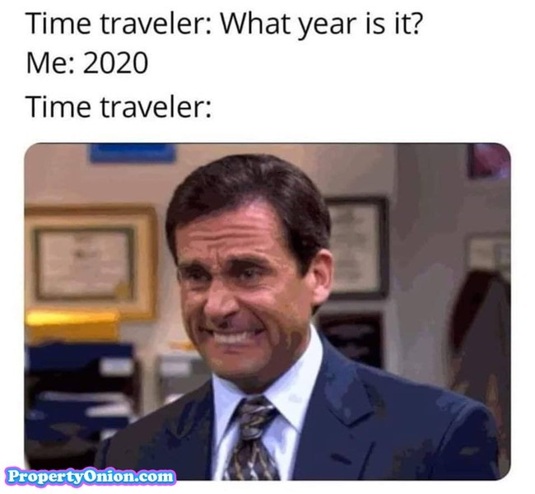
Three COVID-19 Haikus

Times Have Changed

Oh how times have changed
We were once outside, but now
we are stuck inside

Toilet Paper Blues

A virus has spread
Panic ensues. People freak
No toilet paper

Online Classes

Class is now through Zoom
Do I care? I don’t listen
Is it over yet?

