My New Life
Erick Salazar

I am anxious, and it soothes me to express myself here. It is like whispering to one's self and listening at the same time. —Mina Murray in her journal in Dracula, by Bram Stoker

As a way to keep my overall sanity and keep the anxiety away, I find myself able to escape from these uncertain and difficult times through my writings as well as documenting everything for future generations to hear. Wanting to be free from the madness and the feeling of being entrapped in my own home, I turn to the paper for salvation and through this salvation I leave tales for my children and my children’s children. Never would I have thought a trip to the market or pumping gas could be taken for granted, but thanks to this Coronavirus pandemic, here we are. Now I must be sure to keep my distance from others not for personal space, but for my own safety. I find myself being weary of what I come in contact with at the gas station not because I am a germaphobe, but because I may contract a deadly disease that I might bring home to those I love. My writings will tell the tales of what we all had to endure during this worldwide pandemic, forever immortalizing my stories.

Together/Apart
Digital Contact

During this time of social distancing I am trying to stay connected through the various communication outlets we have readily available. With my friends I am able to stay connected through our gaming network and have conversations with them there. We are able to catch up with anything school and work related, as well as keep one another sane through this tough time. I stay connected with my co-managers at work through emails and Skype. We have a couple conference calls a week to catch up on anything we need to be working on as well as any projects we have been able to complete as we get prepared to go back to work hopefully in the near future. Furthermore, I stay connected with my professors and classmates through Zoom and Canvas. My family tries to stay home as much as possible and limit the visitors that we have come over. We do not allow just anyone to come over anymore and we basically only leave if it is work related or for groceries. I believe the biggest challenge has been keeping up with school and work. This quarantine hinders our mental states in such a way that just makes everyday tasks so difficult. I have noticed that I have fallen behind in my schoolwork because of the lack of motivation that this quarantine is bringing upon me and the same goes for my work life. As the days go by, I can feel that we are getting more accustomed to the lifestyle which in a sense is making this a little more bearable, but not sure for how long.

Barren Playgrounds

Typically-crowded places have been left barren as a result of the Coronavirus pandemic, and it has people thinking of how wonderful it would be to be able to visit these places in their newfound empty state. The two places that first come to mind for me are the gym and Disneyland. These are two very obvious responses that you may hear many people say, but they are very reasonable picks. The gym being crowded almost always results in your workouts last three hours or more when in reality it should only be about one hour in total. The crowdedness of the gym also impacts what workouts you want to do and the effectiveness since many people have routines that they like to follow which involves specific workouts being down one after another. Secondly, Disneyland has the insanely long lines that can be up to three hours long just to get on one ride. Obviously, these lines result in visitors not being able to get on every ride in one day so eliminating the crowds would be amazing in this setting.

PROMPT: INFODEMIC

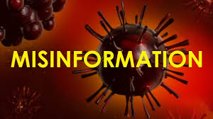
Fake News

The virus itself is not the only danger, so is the inaccurate misinformation about the pandemic. The spreading of misinformation can just cause more hysteria within everyone or even put more people at greater risk of danger. The worst misinformation that I feel that was being spread is that the virus is not real and is just a ploy by the government to make these drastic changes such as the crash of the stock market. This is just plain silly and puts so many people at risk of contracting the virus by making them think it is not real. These people are the ones that remain out and continue trying to live life as if everything is fine. This does not only put themselves at risk, but the ones around them as well.

At Home Sports

With all professional sports being canceled due to the pandemic, we all must find a different way to get our sports fix. I myself am a huge sports fan and being able to watch any types of sports game daily was sadly a luxury I took for granted. In order to get my fix, I have found myself watching replays of past games on YouTube or on sports channels when they show replays. Although this is not the same as watching a live game that you do not know the outcome of, it is very nice to be able to be nostalgic and watch past games. As well as being able to watch past games I find myself playing a lot more myself which is a great way to stay busy during all this. Being able to play basketball outside in my driveway is a great way to get my basketball fix in as well as staying active in a time that we find ourselves staying in bed all day.

Pandemic Medicine

Laughter is the best medicine during difficult times. Rather than sitting around sulking on dark times and issues it is best to try to make light of it to help yourself get over it in a sense. I think this pandemic is no different and it should be laughed as we are all being affected in somewhat the same way. We are all suffering from the same fear within these harsh times and it is best to come together with laughter rather than with fear. We should all be there for each other and what better way to come together than in laughter?

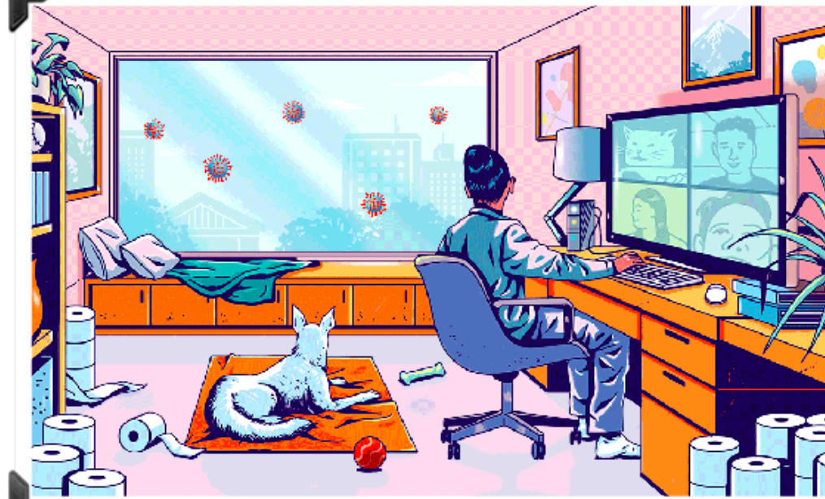

Life for Now

Life as we know it? I am definitely not someone I would consider a homebody. I am definitely not someone who is able to be productive from home. I am most definitely not someone who enjoys being in pajamas all day and being lazy just lounging around. Never thought everyday life could be taken for granted. All I can think of are the little things like fighting for parking at school and rushing to get my morning coffee before work. Is this really how life is going to be now? I guess I can grow accustomed to staying indoors and reminiscing on how life once was, but I would be lying if I said I did not wish for this to end sometime soon.

Haiku-19

I’m staring outside
All I want is my freedom
But yet I stay in

Here with my best friend
We have all necessities
We are safe for now
Toilet paper stocked
Zoom meetings for work and school
This is now my life

