Stuck Inside
Jonathan Argueta-Cruz

Before writers are writers, they are readers, living in books, through books, in the lives of others that are also the heads of others, in the act that is so intimate and yet so alone. —Rebecca Solnit, Flight from the Faraway Nearby

Writing does not forget the emotion I insert in each word. It will allow the future generations to know how I felt during this crisis. We have plenty of time on our hands now, but those seconds are meaningless to me because there is no meaningful memory attach to it. Writing is a scapegoat for me and for others who are in the same predicament. The words that I write down have the ability to travel around the world in the comfort of my home quarantine. When I'm older and stumble on this assignment, it will give me flashback of what occur at that time. These assignments I wrote are full of my thoughts and feelings during this pandemic. Writing my life allows me to chronicle my emotions, thoughts, and events that occur during this global pandemic. When this is all over my writing will not be forgotten and my experience will live on forever.

The Start of Something New

During this time of social distancing I am trying to stay connected with reality because when we were told to stay at home and quarantine with our family, I did not believe this was happening. Social distancing is when you keep 6 feet away from people in public. My family and I are participating in social distancing, by not leaving the house, and if we do go outside, we try to stay 6 feet away from others and wear mask and gloves to protect me and others. The greatest challenge that I face is trying to stay at home and adjust to this new norm. A joy that I found during social distancing is waking up and not needing to get ready for school, which gives me more time to sleep. The way I am staying connected with my family and social groups is in social media because it is a safe and secure way to interact with people. It is starting to get difficult to continue to live in isolation because I’m very eager to go back to our lifestyle and do the fun stuff again.

Going to Staple Center

If I had the opportunity to have a typically crowded place to myself it would have to be the Staple Center. As a basketball fan the Staple Center has been a place for many amazing basketball moments and being able to walk around the stadium and go through the locker rooms would be a dream of mine. I also want to go to Staple Center because my favorite NBA team the Los Angeles Clippers plays in that arena. It will be cool if me and my friends could play basketball in an NBA court and recreate NBA plays.

The Need for Sports

As of now, the NBA has temporarily suspended the season, and for any basketball fan, how does one get their sports fix during this COVID-19 pandemic? As a basketball fan, there is nothing better than watching an NBA game live, especially with the season we are having. Being a Clippers fan, it hurts me not watching them play playoff basketball. As of now, I could only imagine the possibility of the NBA season coming back where it left off and waiting for the commissioner of the NBA to uplift the suspension. This pandemic has taught me not to take everything for granted and to cherish the little things such as NBA games.

Cracking Down False Information

The virus itself is not the only danger; so is the inaccurate misinformation about the pandemic. One theory that I saw circulating the internet was that people were getting the Coronavirus because of the new 5G tower and the radiation it gives out of your phone. I got this information from Twitter and how people were saying they believe it, but I didn't believe this claim was true. I could see why people think this theory could be valid because whenever there is something crazy, people believe it. This information is harmful because I was reading that people were burning down the 5G towers, which put them and others in danger. Many experts say 5G is not the cause of Coronavirus. "Facebook, Google, and Twitter said they were removing misinformation about the coronavirus as fast as they could find it, and we're working with the World Health Organization and other governments organization to ensure the people got accurate information" (NYTimes).

What the Eye Could See

LIFE AS WE KNOW IT?

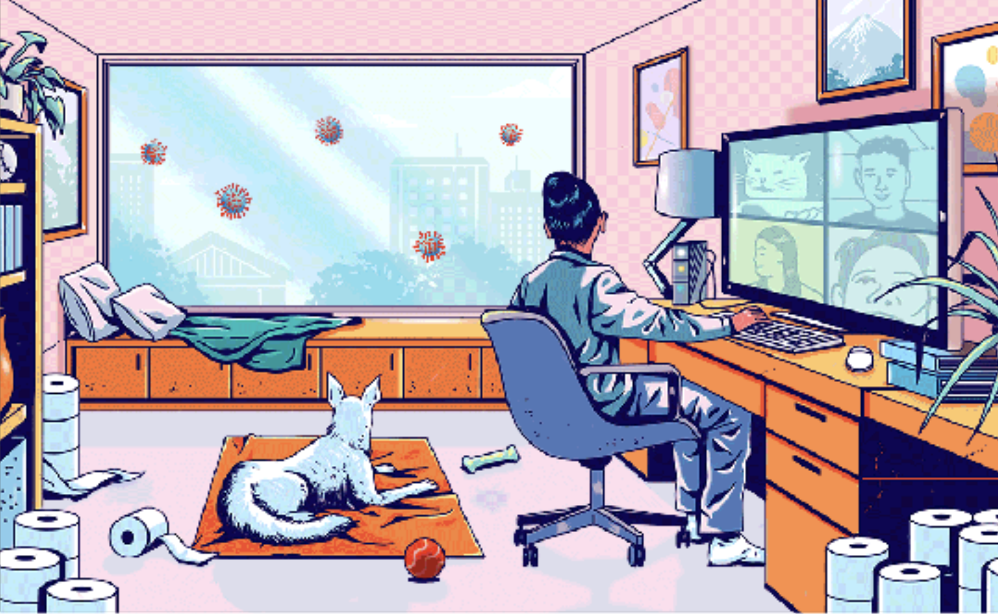

Life as we know it is not what we envisioned doing in this new decade. On the first image, it shows a girl in quarantine, having an online meeting with her friends. It also seems that she has been hoarding toilet paper and is looking out her window watching the coronavirus trying to get in. The dog looks scared because he has his ears pointing up. During this pandemic, it seems that the girl and I are doing the same thing in participating in zoom meetings and looking out the window and wondering when all these will be over.
PROMPT: HA HA!

Is It OK to Laugh During Dark Times?

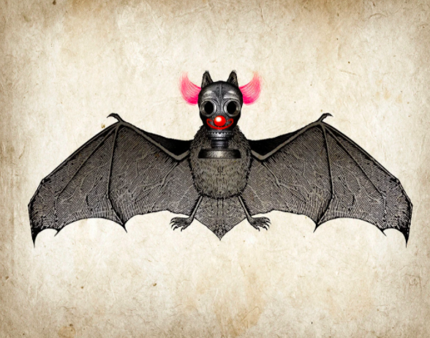

Could Laughter be the New Medicine?

Laughter is the best medicine during difficult times. I agree that “laugher is the best medicine” because it’s a way to relieve yourself and helps you take your mind off of things. Laugher and humor play a significant role during this quarantine because it gives me some type of hope that all of these will be over, and I also think if it weren’t for humor, I would have been depressed seeing the things in the news and bring my mood down. I believe that I use humor as a coping mechanism because whenever I see something funny about the coronavirus, it makes me happy at that moment, and It’s a good way for you to have some type of joy during this pandemic. I do see coronavirus memes and jokes all over social media, and some of them are funny, in my opinion. I do think that some topics or events should not be used in comedy, and it all depends on how sensitive the subject is.

Haiku Poems

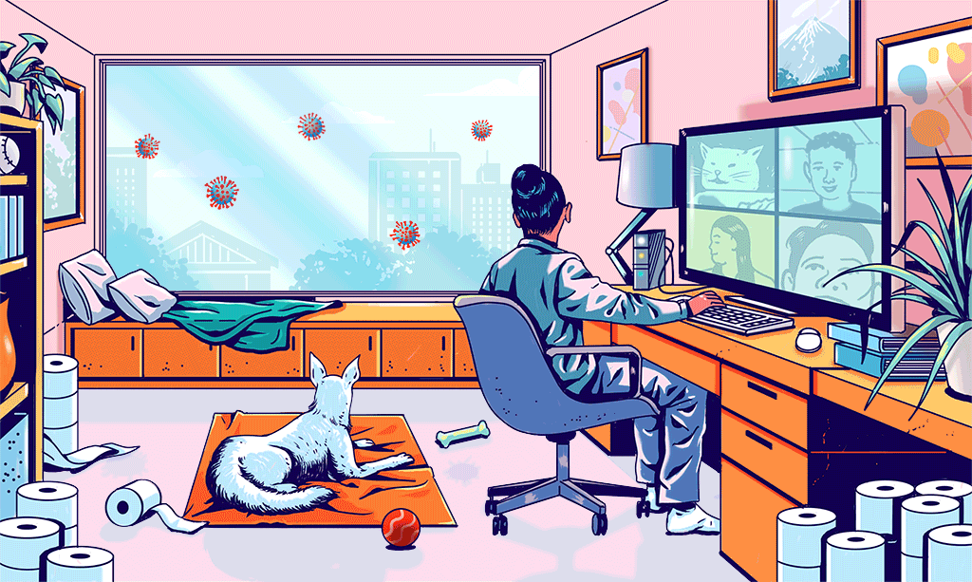
Picture #1

The Thing Outside the Window

What is that outside
What could it possibly be?
Something never seen

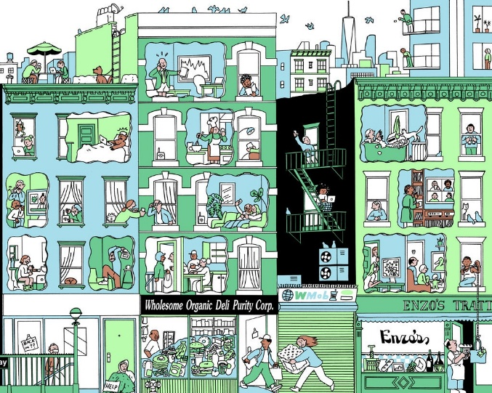
Picture #2

Together We Can

Stay home together
We need to help each other
Lending a helping hand

The New Reality of Life

Stuck in quarantine
A new daily routine
We all feel fatigue

