What Can Writing Do For You?
Kate Delgado
Writing isn’t something you only do in school, it can become a passion. For example, it can help you deal with your fears, it can motivate you, and it can have a positive impact on not only yourself, but others. Writing has the ability to help people express their emotions, feelings, and some feel the need that it is the best way for them to jot down their ideas. During this pandemic it was hard for many of us to follow the rules like staying six feet apart away from each other, no social gatherings, and wearing face masks all the time because everything was so new to us. Expressing your thoughts and feelings on a paper can help you find your true selfhood, where you feel at peace. Even though we are going through a pandemic it doesn’t mean that we could slack off, it means that we need to keep on going. This pandemic is something that we have no control of, but it is something we will remember forever. Thus, with writing I am able to record what is going on in my life and show what it was like during this pandemic.
PROMPT: TOGETHER/APART

Social Distancing

Social distancing is a set of actions taken to stop something like a disease or infection. The main goal for social distancing is to stay away from others and social events such as concerts, amusement parks, and festivals. My family and I are taking social distancing very seriously which is a good thing because everyday this Coronavirus is getting worse and worse, and I wouldn't want to catch it by going out and risking not only myself, but my family. The greatest challenge for me during this social distancing is that I am more focused on school and it is making me become more closer to my family. I am staying connected with my family and social groups virtually rather it be texting, zoom, or Facetime. In my opinion, it is getting harder to continue living in isolation because there are more and more cases everyday and it is always a risk going outside and getting our necessities.

Empty Spaces

Most people want spaces where you can have fun with other people for example, concerts, amusement parks, festivals, and parties but, for me I’d like something more on the peaceful side. For example, being alone or being at home. Being alone is where I find my inner peace. Also, when I am alone I can clear things off my mind which I really enjoy doing because then that leads me to being stress free. Another space I'd like to have to myself would be my own room since I have to share it with my older sister. Typically-crowded places I dream of having all to myself would be amusement parks and malls. Yes, I would visit amusement parks and malls without having to wait in lines. I'd enjoy both amusement parks and malls because personally I don’t like places where it's too crowded because then I get irritated fast, but that's just my personal preference.

Music During this Coronavirus Pandemic

We somehow always turn to music when we are feeling all kinds of emotions. Music has different genres such as sad music, happy music, jazz, rock, etc. Music can take away feelings when you may be sad, happy, or nervous. Not only that but, Music helps us express our emotions in a positive and negative way. Many people when they are listening to music dance, but sometimes others just tend to get emotional and cry. We turn to music during times like this because it distracts us from thinking about hard times like this and it makes people more stress free. This pandemic has not affected the music I am seeking out and listening to. The type of music that I find myself gravitating towards would be calm/soothing music. The type of music I've been listening to recently is pop and electro music. Certain artists and songs make me feel uplifted because once I start listening to them I immediately get excited. A song that is important or significant to me right now would be “Selfish” by Madison Beer. Music can affect how we experience painful or difficult moments in life because we can relate to songs with meaning. For example, heart broken songs. Songs can already be powerful, but it is the lyrics that make it powerful. Others don’t care about the importance of lyrics, they may listen to music just because they enjoy the rhythm.

Has this pandemic given us false news?

I found my information buzzfeednews.com with the title of “Here’s A Running List Of The Latest Hoaxes Spreading About The Coronavirus.” This typical article attracted me because it had different types of false information about the Coronavirus which was really interesting to read about. Some false information about the Coronavirus were believable and others weren’t. For example, the unbelievable one was that a cure for the novel Coronavirus includes colloidal silver, vitamins, teas, and essential oils, which none were approved as being a treatment to the virus. On the other hand, a believable aspect of this article was when a celebrity had posted an announcement about the Coronavirus which gave some advice on how to prevent getting the virus. For example, how Japanese doctors were telling everyone to drink a few sips of water every 15 min which I thought was true, but still not convincing enough that it will cure the virus. False information can be harmful because people are taking this seriously and they will believe anything they see on social media. I think this harms mostly older people because older people tend to believe everything they read or see. False information does create panic because people tend to panic over information that isn't even true. Promoting false information can be a money-making scheme because in today's society people will do anything for money.

Life During This Pandemic

Life as we know it. The first story currently inspires my own life right now due to the fact that that is my life right now. We are all going through quarantine and switching to online school. It honestly sucks that this is how we have to live our life, but all we can do is to stay positive and follow orders. For example, staying 6 feet apart, do not have any social gatherings that are more than 10 people, and most importantly staying home. In this image I see a person on Zoom, stocked up on toilet paper, and a person looking outside wishing they could be outside, but all they see is the Coronavirus which all this does reflect on me and my life right now. I also believe that everyone can relate to this image because it is true, once we look or think about going outside we have that fear of “oh i'm going to get the Coronavirus.” This image makes me think about how life is going to be after this is all over. I predict that it will not be over until 2021 because a lot of us don’t follow the orders that are requested of us. This image makes me feel emotional in a way because this whole situation ruined many things like graduations, senior events, jobs, etc… Another huge reason why this situation has made me feel emotional is because it has affected me and my motivation to keep continuing school due to the fact that it is difficult for me to learn virtually.

Is laughter the best medicine?

Often people do say that “laughter is the best medicine” because Laughter reduces pain, increases job performance, connects people emotionally, and improves the flow of oxygen to the heart and brain. Laughter reduces pain and allows us to tolerate discomfort. I do find this true due to personal experiences. For example, when I’m sad my sister always tries to cheer me up by making me laugh, and it does work. I have also seen it work with children. Laughter and humor play in my life during difficult times like these as a role of my body relaxing, inspiring hope, connecting to others; it helps me release anger, and forgive sooner. Yes, I would say that humor is a coping mechanism because it helps others adjust stressful situations while helping their emotional well being. Honestly, I have laughed at Coronavirus related jokes and memes. And no, the examples from the articles were not funny to me due to the fact that the articles were more on the serious side.

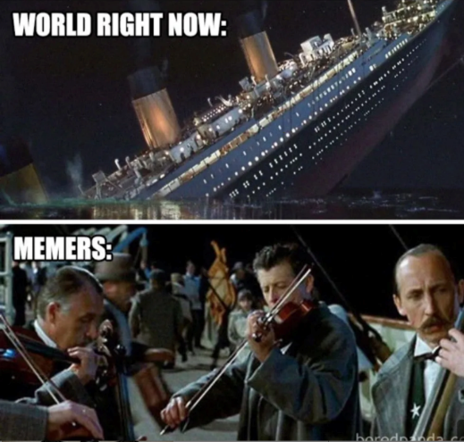
HAIKU #1

Coronavirus
It stopped us from going out
Made us go crazy

HAIKU #2

What a pandemic
Going crazy for water
Going nuts for soap

HAIKU #3

I am unhappy
I’m losing motivation
But want to succeed

