My Current Thought
Jossely Narvaez

In the journal I do not just express myself more openly than I could to any person; I create myself. The journal is a vehicle for my sense of selfhood. It represents me as emotionally and spiritually independent. Therefore (alas) it does not simply record my actual, daily life but rather—in many cases—offers an alternative to it. —Susan Sontag, Reborn: Journals and Notebooks, 1947-1963

Journaling was never one of the things that I thought I would like. In my junior year of high school, I started journaling because it was an assigned assignment we had to turn in for my English class. Throughout that experience of journaling, somehow when it can to writing about what my actual feelings were. I never felt that the work I produced was my sincere thoughts, just a cover-up of my actual feelings. It felt like I was always holding back on my real emotions when it came to my actual thoughts on certain matters. Now that has all changed because this Coronavirus pandemic made me realize that I should not keep my feelings to myself; instead, I should express myself so the world can know how I truly feel about this virus going around through my journaling. This crisis has made me realize that I have a story to tell and that my voice should not be stopped. Thus, I will be writing down what I truly feel about this crisis so that one-day people can understand what happened in the world during this time.

Together/Apart

During this time of social distancing, I am trying my best to stay connected with society by having video calls with my friends and texting them at random times. Social distancing is keeping space between you and the people around you. It is recommended to stay 6 feet apart from one another and not engage in large gatherings. It has been difficult not to go hang out with them and stay at home instead. All my life I had the ability to walk outside my door with no worries, yet with this pandemic of COVID19 going around the world, things have been changing drastically. Now my family only goes outside if we have to go buy groceries, attend work and walk my dog. We used to have the leisure to go out and do anything we wanted but things have changed and they will continue to change if we down slow down the curve of this pandemic. That is why we have to practice social distancing, to lessen the number of people getting effect with COVID19. Not having the ability to socialize with my friends is not the hard part of staying at home because I am somewhat of a homebody. My greatest change is not socializing with my friends but instead, it is staying at home and doing all my classwork. When I was on campus, I had many places to get my work done in silence. Now that I am at home I do not have that peace and quiet to concentrate on my work, making it the greatest challenge of mind to study at home. Going to school was an escape from home, where I could have some personal time and space. Now that I am at home I do not have that time for myself anymore. That is why I have been calling and texting my friends at different times so that I can remind myself that I have people that care about me and it not just my family.

Big Hit Entertainment All To Myself

A typically crowded place that I would love to have to myself would be a Kpop company building, to be more specific it would be Big Hit Entertainment. It is located in Gangnam, Seoul, South Korea, in an international hot spot for foreigners to have fun. It also has approximately 600 employees. The reason I chose to be in a building instead of a tourist spot like the Louvre Museum in Paris is because I think I would be more personally invested and have much more enjoyment in a company learning about something that I like, Korean pop. Once I am inside that building I would love to see where BTS (Bangtan Sonyeondan), a seven-member boy band and their producers create their amazing beautifully lyrical songs. I’d visit the Rkive studio, Genious Lab, Hope World, Golden Closet, Adorable Trap, Dogg Bounce, Carrot Express, The Rock Pit or in the many other studios that the company has in its building. I would also be able to see the company’s artists' dressing rooms where all the fashionable iconic clothing their artists have worn for the many tours, award shows, comeback events, and foreign affairs events are stored. Going into this building would be like going into my own museum about Kpop, but instead, it is just a 19-floor building with 7 basement floors. I would be like a building inspector because I would be inspecting every single nook and cranny in that company’s building. Having that place to myself would be a dream come true because I would learn so much about that Kpop company’s management and its artists. There would be so much to see in Big Hit Entertainment because they have many spaces like their cafeteria, vocal rooms, dance halls, music studios, dressing rooms, and their corporate side of the building. So if there is any place in the world where I would love to visit all to myself it would be Big Hit Entertainment.

The Meaning Behind My Playlist

During this Coronavirus pandemic and social distancing, music has played a big role in comforting me through this stressful time. Before this pandemic started I was listening to Doja Cat’s, Hot Pink album on repeat. When listening to her album, I just felt like a badass college student. Even though some of her lyrics are questionable, her songs still made me feel powerful. Currently, I still listen to her songs, but now my music playlist is focusing more on the lyrical content that the song provides. I listen to songs from different parts of the world. Right now my stay at home playlist consists of songs in Spanish, English, and Korean. For starters, a Spanish song I keep listening to is “Yo Perreo Sola” (I Twerk Alone) by Bad Bunny. It is an Urbano Latino song with a catchy beat that makes you want to dance. At first glance, the lyrics seem questionable, but once you read the lyrics again and see the music video, you will see that this song is a women's anthem for Latino and Hispanic people. This song is about a young girl trying to have a fun dance night out without getting harassed by people, especially men. The song gets more meaningful when you watch the music video because Bad Bunny is dressed in drag, chained by queens, and in one instant you see a neon sign that says, “Ni Una Menos” in other words “Not One Less.” These scenes and signs are meaningful because currently across Latin America there is a gender inequality movement. This song is a good example of the current protest happening across Latin America with women and queer inequality rights. Furthermore, Bad Bunny brings awareness to this in his music video. That is why I keep listing to this song because it is a reminder about what women and queer people are fighting for in Latin America.
The next song in my playlist is a Korean pop song by Apink called Dumhdurum ( \Dum-Durum\, the sound a heartbeat makes). This song has a 90s funky vibe that I like, which makes me want to dance and sing with them and forget about the pandemic going around. This is a sad song about the relationships these girls had in their past. The lyrics consist of loneliness, denial, only hearing sad songs, and leaving a relationship because they love their partner so much. It is a sad song, but it sounds happy and funky, which is why this song is a sad bop. The music video to this song is very colorful and tells a story. If you follow up with their previous two song releases then you will understand the full storyline of the music video. This song is a part of a trilogy series with “I’m So Sick,” “Eung Eung (%%)” and “Dumhdrum” being the final one. I have been following them for the past three years and like the growth in music they have accomplished. This is the reason why this song is in my playlist, besides it being a very catchy song.
When it comes to my English music, it is currently being dominated by Tik Tok. Before the pandemic, I did not have a Tik Tok account, but since I have been so bored at home I decided to download the app and see what is going around. While on the app I heard many catchy songs with very nice beats. After seeing people create videos with 60 seconds clips of the songs, I decided to search the songs and listen to the full release versions of them. Some Tik Tok songs that I have in my playlist are “Envy Me” by Calboy, “Blueberry Faygo” by Lil Mosey, “High Fashion,” and “The Box” by Roddy Rich. These songs did not start on Tik Tok, but this platform blew them up. I listen to these songs frequently because the beats are very nice and catchy. Some of the lyrics may not be appropriate sometimes but the flow and rap verses are just perfect.
Hearing the flow and beat of a song was the old way I used to hear music. Going through this pandemic has changed my process. At first, I did not care about the lyrics and easter eggs in music videos. I would only hear music based on how the beat made me feel. Now I am interested in seeing the full picture of a song. Instead of just hearing the beat and flow, I listen to the lyrics the artists write about. I still listen to some songs that make me want to dance, which have some controversial lyrics in them, but now I consider the value of the words. This pandemic made me realize that songs can be meaningful and catchy at the same time, and I am thankful for that.

YouTube’s Changes on COVID-19

The virus itself is not the only danger we are facing, so is the inaccurate misinformation about the pandemic. In the past two months the Coronavirus has spread to the entire world leading people to get scared about contracting the virus. If you login to any social media platform right now, all the buzzy in the main pages is about COVID-19. With everyone trying to make videos about this virus, misinformation happens and spreads fast through social media. That is why some social media platforms are starting to take care of what information should be posted online. For instance, YouTube has started to roll out monetization content dealing with any “mentioning or featuring COVID-19.” They also set in place rules and restrictions about the coronavirus. If a creator misinforms anything about COVID-19 or distressing footage, medical misinformation, pranks, and challenges. Their videos will not be uploaded to the internet. Youtube states that “Above all else, Youtube priority is providing information in a responsible way,” and you can see that as they direct their viewers looking into the latest on Coronavirus to the home page of the CDC. Misleading information is harmful, that's why we have to make sure that we are reading and looking up information that is accurate, and Youtube is making that their priority to ease off this stressful time.

Life as We Know It?

“Life as we know it,” is changing rapidly due to this Coronavirus pandemic. I used to have all the luxury in the world to do anything I wanted, but that has quickly changed to the image you are currently seeing in front of you. It is crazy that the image is a clear vision of my current lifestyle. It is so more laughable that my life can be easily compared to that picture. At the beginning of this first year in college I started exploring the city of Los Angeles a little bit more. By the end of the fall semester, I had it in my routine to go out on the weekends and try new cafes in LA with my friends. I was so ecstatic, every weekend I would go hang out with my friends, but that quickly changed when the Coronvirus became a pandemic and California declared its Stay At Home Order. When Governor Gavin Newsom stated the order, I was happy that he was taking care of California, but I did not foresee how my life would change. Now, my lifestyle is easily compared to that image you see. I sit at my desk and wait for my Zoom calls with my professors and video calls with my friends. I also see my dog chill all day long and get overjoyed when we go on walks. All my days consist of working on my assignments and only stepping outside when I have to walk my dog. Due to the COVID-19 my life as you know it now is like that image you see right in front of you.

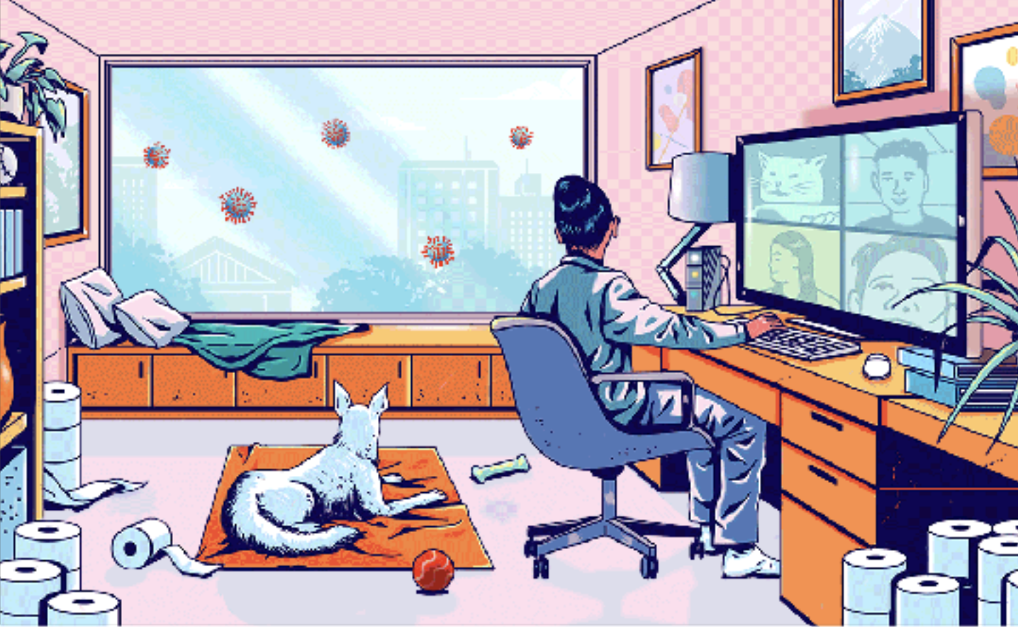

My Laughter through COVID-19

Laughter is the best medicine during difficult times. It may seem selfish to laugh about something related to the Coronavirus, but it is one way that people can forget about all their worries during this stressful time. At first, when people were starting to create memes about the virus, I personally thought it was not funny because they were not understanding the severity of the issue. Now that we are more than two months in, I retract my statement. Creating memes about the virus is a way for people to distract themselves about staying at home and social distancing. It is also a way for people to see the methods of how other people are dealing with the issue. They are so many Tik Tok’s regarding the Coronavirus about mental health awareness, jokes, keeping active, story times, and more. These Tik Tok videos are a stress reliever for multiple people. One of my favorite Tik Tok videos that makes me laugh all the time is about Rex from the movie Ice Age trying to wash his hands. Sid tells him to wash his hands because the Coronavirus is coming, but Rex could not wash his hands. Rex is a T-Rex with short arms and because he could not wash his hands-on time, he contracted the virus. This video makes me laugh all the time, especially since it is in Spanish and the person doing the voice-over did an amazing job. This video makes me laugh and it reminds me to wash my hands. Laughing is a way to relieve stress and theses videos and memes are helping become less stressful during this Coronavirus pandemic.

My Haikus

Boredom to the MAX

I want to get out,
I want to leave my house, Why?
Because I am bored.

Laziness

I was waking up
On-time, but that quickly changed
Now I am lazy.

Toilet Paper, Where Are You?

Oh my God Help me,
I need toilet paper, please
Where is the TP?!

Staying In

Didn’t even know
It was becoming a norm
For me to stay in

My Mother’s Heroism

During this difficult time of the Coronavirus pandemic I have seen my mother’s heroic action in helping out the need. My mother has been working at the same retirement home since I was young. When the COVID-19 started to spread in California, I was worried about my mother’s workplace because her job has a lot of retired people who can contract and spread the virus very fast. When the virus was confirmed at her job, I was scared that she would contract the virus and that something horrible would happen to her. Thankfully, when she got tested, her results came out negative for COVID-19. My mother has always seen old people die at her work throughout the years, but she has never seen multiple people die at once due to a virus. The people she works with were getting sick and the elders she created relationships were vanishing from this earth like they were never there. I have never seen my mother cry, but this pandemic brought my mother tears. Knowing that she can contract the virus is a scary thing for my family because we are asthmatic prone. Yet, she continues to attend her job because she knows that they are not that many people who can help out her workplace. My mother has seen things that I might never witness in my life; yet, she is trying to stay strong because she knows that this is going to pass and that something wonderful is going to happen when this pandemic is over. I have seen how my mother suits up when she attends her job because she has shown me pictures of herself. She is literally covered from head to toe in protective garments. I am so proud that she continues to do her best at her job for the safety of others. I could never be much more proud of her in continuing this hard journey. Thank you for your heroism mom in helping during this pandemic.

