Writing our Memories
Diana Citalan
Never forget that writing is as close as we get to keeping a hold on the thousand and one things—childhood, certainties, cities, doubts, dreams, instants, phrases, parents, loves—that go on slipping, like sand, through our fingers. —Salman Rushdie, Imaginary Homelands: Essays and Criticism 1981-1991

Time has been tough these past few months. All of a sudden our daily lives have turned over to something none of us have imagined. We are suddenly being forced to stay in our homes, somewhat isolated from the rest of the world. It never occurred to me that affectionate acts such as hugging are suddenly prohibited for safety measures. Writing is one way I could express and communicate my thoughts and feelings about this pandemic going on. It is a way to speak my mind about how things have drastically changed. I know that in the future when all things get better, we will look back and remember about the hard times that we all went through. Some of us will vaguely remember but that is why writing can help us remember the little details about this situation. With our writings, we can keep a memory about how the coronavirus pandemic made us feel, and what we went through, and with these memories, we can tell our future generations of the history we lived. Through the act of writing, my thoughts will be captured, maybe not for future history book purposes, but to remind me, those around me, and future generations of the effect this pandemic has taken on us.

So Far Away

For safety precautions, the government and health officials have established social distancing. We are required to stay at home, and if it is necessary to go out we must protect ourselves and stay within 6ft of each other. I have stayed at home most of the time. My parents are usually the ones going out for work or for grocery shopping. Every time one of us has to go out we make sure to wear our masks and gloves. It has been hard because there are times when my siblings and I have wanted to go out but we have to remain at home. Sometimes we invite our closest relatives over to enjoy some time together while still following the rules. That has been some of the joy I have gotten because we get to pass some nice family time. Classes and school have somewhat gotten hard as well. I have lost motivation to do work but I know that my grades are still important. However, to make things a bit easier I have stayed connected to my friends and classmates to help one another on our work. I call and Facetime my closest friends every day to keep our communication up because I wouldn’t want to lose them over the lack of communication. I’m sure everybody is struggling with the social distancing, but if we maintaining following the rules, the pandemic could end sooner.

A Place of My Own

I enjoy having time to myself. There are some activities that I enjoy doing by myself than having to share someone’s company. Don’t get me wrong, I enjoy being surrounded by friends and family, but I feel most at peace when I only have myself. One place that I would love to have by myself is a Barnes and Noble store. I love to read; I love to get lost in a good book without any distractions. Some Barnes and Noble have a Starbucks within their locations so that will be a bonus. I can make my favorite drink or experiment with a few ingredients and create my own drink. I could then choose a favorite book or read a newly released bestseller. I would pick out a brand new copy of the book and enjoy the feeling that it is new, and it has never been opened. I would make sure to sit down in a comfortable place and just enjoy myself while lost in a book. If I finish it, I would continue to read more and more books until I can’t anymore. Having a Barnes and Noble all to myself would be a dream come true.

A Strong Get-Away

Music has always been a stress reliever for me. It doesn’t matter if I am having a bad or good day, if I’m doing chores, or if I’m on a car ride, I listen to music. Something about it makes me feel good and it always lifts up my mood. Now, more than ever, I have caught myself listening to music more than other times. I usually listen to one genre of music but lately, I have been listening to other genres and new artists. Just a few days ago I felt like listening to “oldies” such as “Hotel California” by Eagles, “Our House” by Madness, “Sweet Dreams” by Eurythmics, and a few others. I suddenly got the mood to listen to them and so I did, then after I started listening to a few songs by Michael Jackson. I believe music has been very helpful with social distancing because it keeps me motivated. I know that some artists have also been creating music to help with social distancing such as Ariana Grande and Justin Bieber with their new song “Stuck With U.” I know this song has a strong message because it was made to bring positivity and it is also for charity purposes. Music has the power to change the world and send strong messages, and it has definitely helped me through these hard times as a getaway.

Fake News Are As Harmful as the Pandemic

Many information has been released about the coronavirus, some are true and some are not. Like many other big events that hit the news, false information is sure to spiral up. One of the false information relating to Covid-19 is that it was created or released by people. At one point I did believe this was true because many people start creating their own conspiracy theories and eventually people start believing and sharing the false information. However, the truth is that viruses that exist in animals can mutate and undergo changes and with these changes they can be passed down to humans. This is what scientists believe happened. This information can affect many. It can affect the people from the place this virus originated from, creating hate comments and racial discrimination as we have seen happen. This information/misinformation has created panic as much as the Coronavirus itself due to people not wanting to visit its place of origin. This virus could have started anywhere since us humans rely on animals for food, and we all know animals are unsanitary and carry many harmful pathogens: The New YorkTimes writes, “ Posts and videos that shared conspiracy theories were clearly marked as false, once they had been reviewed by fact-checkers.” To make sure false information doesn’t get spread the W.H.O and social media platforms are working together to disintegrate any false information that could have many people worried and create chaos.

How Life Has Changed

Life as we know it has changed. We are required to stay indoors with nothing much to do. In the first image with the girl on the computer and her dog by her side relates to how a lot of us have been spending our days. She seems to be on a video call with her friends. One of the pictures shows a cat from a famous meme, and there are toilet paper rolls all over her room. This girl is somewhat like me. She’s on video calls just like I do most days, but this girl is like many people as well. People went crazy over toilet paper and stocked up thinking that toilet paper will run short. She also seems to be in baggy clothes such as pajamas because since people are not going out at all they don’t find a purpose to change outfits. People are on social media sharing memes all day to friends and family. All of this is due to one situation, the red balls outside her window. They’re not actual red balls, they are the virus. This virus has no cure and nothing that could prevent it, which is why we are asked to stay indoors. We need to keep ourselves safe because life as we know it now, has changed and not in a good way.

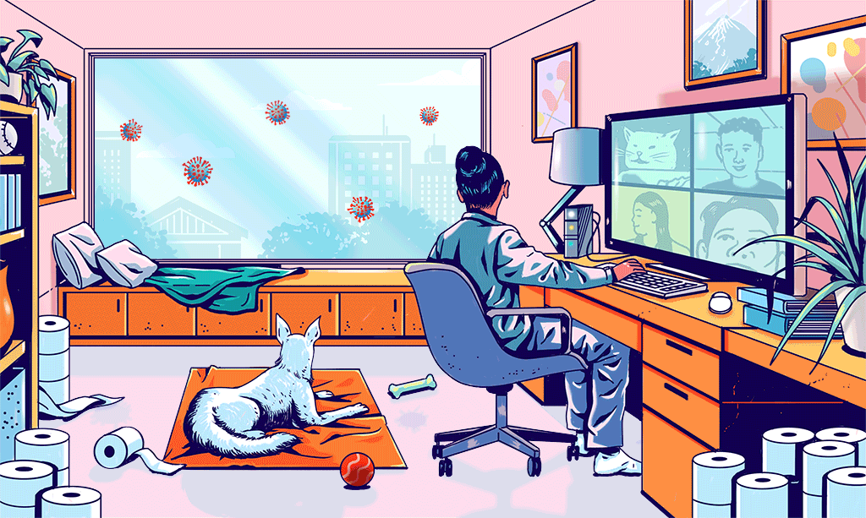
Haikus
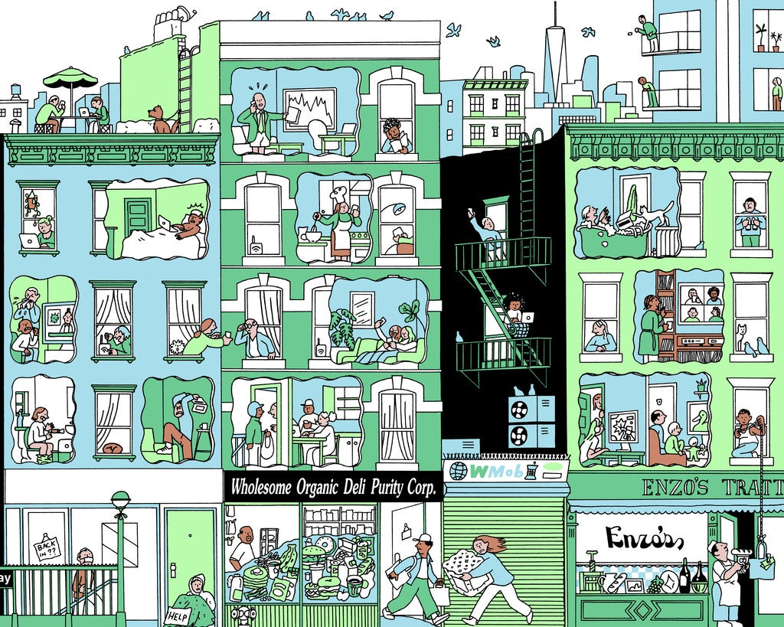

From the girl on the first image

What is that outside?
Maybe I should stay indoors
It does not look safe
From the dog on the first image

Those look like chew toys
I want to go out and play
But mommy says no

From the man in his apartment talking on the phone with no pants on

I now work from home
This is driving me insane
I don’t need my pants

Community Heroes

What heroic acts have you witnessed—big or small—during the Coronavirus Pandemic?
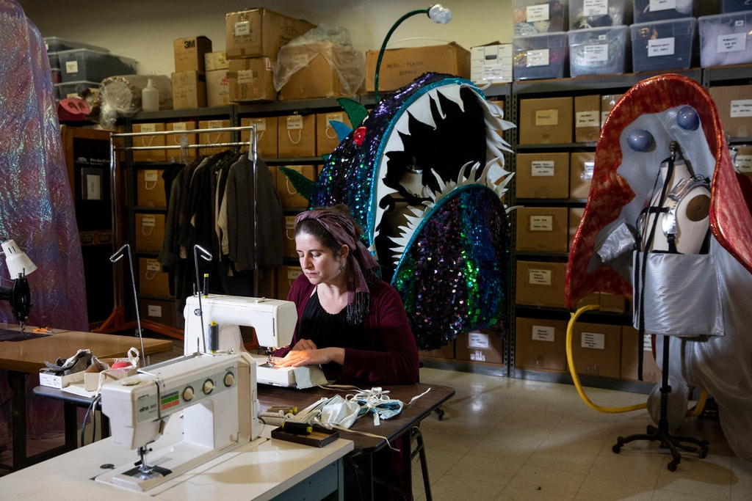

Fred Rogers — known to generations simply as “Mr. Rogers” — famously said he was always comforted by something his mother would tell him during times of disaster:
“Look for the helpers. You can always find people who are helping.”
Corinna Bakken, the Minnesota Opera’s costume director in Minneapolis, stitching masks out of gowns sent by a local hospital. (Tim Gruber for The New York Times)

During this pandemic I have witnessed many heroic acts. There are countless people doing anything they can to help contribute to their community, and I have seen that almost everyone, including big companies are doing anything they can to help. One of the companies that impacted me was Little Caesars. I ordered pizza online and at the checkout Little Caesars had a choice where you can donate a pizza to any first care responder in your area. I pressed the option because I know that first care responders are having a hard time during this pandemic. It touched me because from other restaurants that I have ordered food from, Little Caesars was the first one that I saw that was helping those that need a bit of joy in their life. Another heroic act that I witnessed was my own father. He has a small workshop where he has his own little business. He mainly works with fabrics and because of this he also decided to make some masks. He took a whole day to make about 500 masks and he gave them away to family members, family friends, neighbors, and even people from the church I attend. Everyone greatly appreciated my father for the small gift he gave to those close to us.

