Writing During a Pandemic
Anonymous 1

I am anxious, and it soothes me to express myself here. It is like whispering to one's self and listening at the same time. —Mina Murray in her journal in Dracula, by Bram Stoker

Writing and expressing myself through literature is something I am not used to; however, during a pandemic I do agree that for some people writing is a good way to cope with their emotions. Despite not believing writing is important for me at this time, I do believe it would be beneficial for someone in the future if they were to ever wish to know what going through a pandemic like this is like. And if there are any new pandemics in the future seeing those of the past may assist them with their own ways of coping. We are in a situation that is literally history in the making. As I am left with my thoughts and reflecting on the times I took going out for granted, I have constant recurring thoughts and writing them down helps me move on to a better state of mind. It feels like the weight of my thoughts and emotions are being transferred onto paper and I can move on from them. During the 2020 Coronavirus Pandemic the act of writing my story, my voice is captured and heard.

Staying Connecting, Isolated

During this time of Social Distancing, I am trying my best to stay connected and maintain my inner peace. Social Distancing can be defined as keeping a certain distance from others or avoiding intimate interactions to maintain the safety of others and yourself. My family of six and I have been quarantined together. My dad is a social worker so he has to go to work on Mondays/Tuesdays and works from home Wednesdays/Thursdays while my mom stopped working and going to church since she is in the choir. My oldest brother has been taking online classes for school just like me, my other older brother has just been staying home, and my older sister took a leave of absence right before quarantine began. The greatest challenges have been adjusting to normalizing wearing masks in public and missing going thrifting or busting missions with my friends. An unexpected joy in Social Distancing is going to the nearest Big Lots with my sister to buy a lot of big bags of chips that we binge eat without sharing. My family and I stay connected by watching old home videos on cassette tapes together. Luckily, my roommates and I stay connected by creating zoom meetings to play Call of Duty together. With my other immediate friends, we text to check up each other here and there since there is not much going on in our personal lives during this time. Although I am starting to accept the fact that everything is canceled now, what gets difficult is trying to practice Social Distancing in public when having to run errands since there are a lot of people around, not keeping their distance.

Empty Spaces

Typically crowded spaces I wish I could have all to myself are thrift stores, Six Flags, Downtown Los Angeles, and the Japanese Tea Garden in San Francisco. Thrifting with my close friends is one of my favorite hobbies, but sometimes there are too many people around taking all of the good vintage clothes. Six Flags is my favorite amusement park, but it is always packed and lines for the best rides can be as long as 3 hours. I would really enjoy being able to go on all the rides with my close friends without dealing with the mustiness of other people. Downtown L.A. is always full of traffic, homeless people, drug addicts, prostitution, alley way shoppers, street merchants, random people exploring, and a surplus of shoppers. Being able to enjoy and explore Downtown L.A. without coming across the dangers that normally occur there would be pleasant. However, these are just places I am used to seeing all the time. I have never been to The Japanese Tea Garden in San Francisco; I would love to go there and sit by the peaceful little ponds. I really like the aesthetic of the garden and I feel like having that place to myself would be calming especially during times like these.

Songs That Matter

I cannot stress enough the love and appreciation I have for music. Songs I enjoy the most are usually some that I grew up listening to because of my parents or other surroundings. I love when the lyrics, beats, and background vocals in songs unite bringing indescribable emotions that get me nostalgic. Genres I listen to a lot are oldies, 80s and 90s pop, new wave, classic rock, 80s/90s/00s rap and R&B, 70s funk, psychedelic music, and today’s rap. My favorite song of all time is “Hello Stranger” by Barbara Lewis; I always enjoyed the lyrics, the rhythm, and the harmonizing background vocals. Hearing this song always puts me through something spiritual, and I find myself trying to sing the lead voice, background vocals, and hum to the beat all at the same time. Another song I have always appreciated but recently have had on repeat is, “It’s Gonna Take a Miracle” by Denice Williams, the lyrics in this song make me reminisce about the last person I liked before quarantine started. I am the type of person who likes to embrace the emotions that I am going through when listening to songs that remind me of painful or happy memories. I love taking the time to reflect on things and I feel like the lyrics of these songs help me concentrate on the memories I am thinking back to. The third song that gets me moving and in a good mood is “All Night Long” by Mary Jane Girls. I think this song is a genius art piece, especially since it is produced by Rick James. This song reminds me of heartwarming memories with my best friend, Valentina, who shares the same music interests as me. Appreciating the lyrics in songs is powerful because I feel like it stimulates my brain in a positive way since I love to reminisce and reflect. These songs have kept me sane throughout my life and continue to do so during this pandemic.

Misinformation During a Pandemic

The virus itself is not the only danger, so is the inaccurate misinformation about the pandemic. Misinformation occurring during this pandemic are the false death reports regarding the Coronavirus(COVID-19). According to the Parkersburg News and Sentinel, many deaths that have taken place during the pandemic are reported to be caused by the Coronavirus when they did not. This information attracted me because it shows that people are exaggerating the amount of deaths that are actually caused by COVID-19. This only brings more anxiety upon civilians towards the Coronavirus. This information is believable, considering the fact that Los Angeles has roughly over 37,000 confirmed cases. What needs to be done to halt the spread of misinformation regarding the Coronavirus is for hospitals and Health Departments to stop reporting normal deaths as COVID-19 victims.

Life as We Know it

Life as we know it. It almost feels like yesterday I was living on campus and enjoying the campus life with my roommates. I remember talking to my roommates about the Coronavirus outbreak and the possibility of everything having to be canceled. We all joked about it and claimed that the situation is “dramatic.” Teachers were announcing that they were preparing to convert to online classes, but the possibilities seemed slim. No one would have imagined that life would come to this. My last week at the dorm I felt like my heart was slowly breaking knowing that my roommates and I would have to move back home. The situation is out of all of our hands; it feels like so much was taken away and now there is not much to look forward to.
As soon as I moved out of the dorm, my sister and I immediately started planning on cleaning out, painting, and remodeling our room. The next day, we go to Home Depot, choose our paint, and to our surprise everyone’s planning to make use of their free time by remodeling their homes as well. With all the chores, my sister and I kept ourselves pretty busy during the first week of quarantine so dealing with withdrawals or concerning mental health issues were not a factor. Life as we know it- we have to isolate ourselves from everyone because we do not know where people have been and have to be extra sanitary.

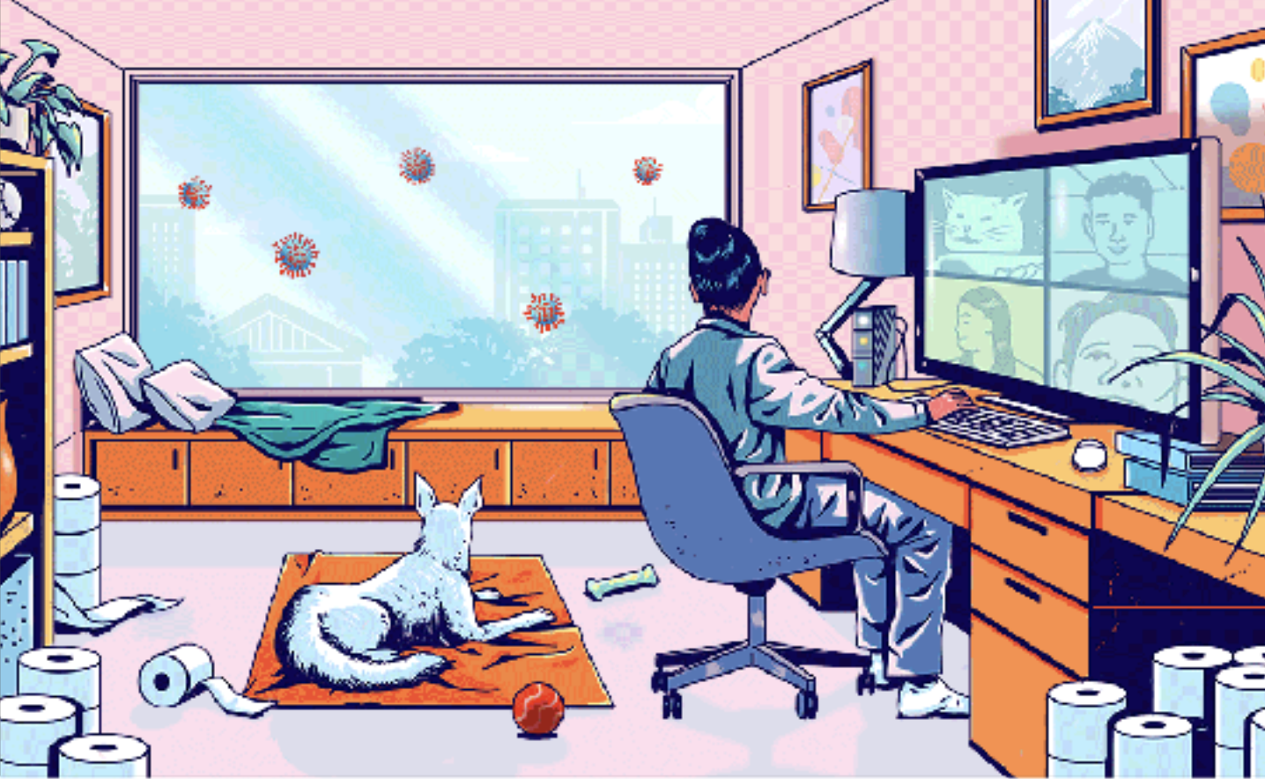

Haiku

Dog’s Perspective

My owner is here
She seems stressed—I am happy
To accompany

Neighbors

My neighbors I can’t
see. I wish for their safety.
We stay strong apart.

In My Room

There is no way to
be certain when this will end.
I just sit and wait.

