Same People, yet a Different Society: The World Changed in One Moment
Jonathan Aguirre

Some may say [writing] is a great deal of trouble. But we should not call anything trouble which brings to pass good. I consider that portion of my life which has been spent in keeping journals and writing history to have been very profitably spent. If there was no other motive in view [except] to have the privilege of reading over our journals and for our children to read, it would pay for the time spent in writing it. —Wilford Woodruff, Journal of Wilford Woodruff

Chronicling my life and making my voice heard during the pandemic is important because it shows a moment in time where humanity is at one of its low points. It reveals my struggle with the ongoing Covid-19 pandemic along with my college work as a student. This typed document archives a time where society changed from outgoing to locked down in their homes in an instant; where the modern use of technology is fully used to provide education and maintain jobs whereas it seemed unfathomable beforehand. Showing my journey through this change offers a chronicle of vast reevaluation not only among myself, but among others in the world as well. As I type each word the quarantine era remains present, but with each keystroke history is being foretold. Remarked as assignment today, but seen as a piece of history tomorrow. As I type during the Covid-19 pandemic of 2020 I plan to make a document describing things I have been up to, how I cope with the added pressure, and the importance of staying mentally stable.

Social Distance, Mental Reconstruction

During these times of human isolation and social distancing I am trying my best to stay connected by staying at home with my family to reduce the risk of infection, taking classes online and playing video games with friends over the internet as this dark pandemic passes by. The reason for this isolation is the ongoing Social Distancing precautions being taken as a way to prevent the spread of the Covid-19 virus. Recently, the term “Social Distancing” has been thrown back and forth constantly the past month and the definition I would give would be taking the measures needed to stop any form of bacterial spread amongst one person to another, thus cutting off a chain of infection. My family and I are practicing this distancing by limiting our trips outside the house unless it is absolutely necessary such as shopping for food, water and other necessities. For the most part, if any one of us gets sick then we would all end up getting sick due to the small living space we rest on so we are taking serious precautions. Unfortunately, the greatest challenge for me personally is being stressed almost every single day due to constant worry about the state of my family’s health as they still go to work under these circumstances. I am grateful we can still support ourselves; however, a huge risk is still present and it worries me sometimes. On top of that, the semester is on the verge of ending, but most of my professors are handing out constant tests and assignments and I can barely keep up. On a lighter note, if there is any sort of joy that has been offered due to isolation it would be not having to travel to and from school on a metro bus for two hours. It was always a hassle for me to take the bus for a pretty good amount of time because just being at school wore me out. I am saving myself money, time and have less risk of being infected by not riding public transport. Also, staying connected to family members as well as other people is very important; thus I usually connect with them via phone, text or video calls. In a pandemic like this, making sure my family is fine and healthy is the utmost priority. Keeping in touch with several of my friends makes it easier to get through and is a constant reminder that we can help each other through each and every moment. Even if we just end up playing video games for a bit, it still calms my nerves for a bit. As we continue to live through isolation I believe it is getting both easier and difficult in different aspects. At first, a lot of people started hoarding stores for any product that seemed usable for sanitation as well as food and toilet paper. After a couple of weeks, things started to get better as people are starting to think more rationally and civilly among one another, at least from personal experience. However, it is getting worse in terms of keeping stores open and people with jobs. I am sure there are a lot of people who live paycheck to paycheck with some pretty high housing costs and this is affecting them negatively. All in all, no matter the various measures humanity can take such as becoming distant from one another, we can only count on each other to prevent such a pandemic from moving forward.

Nevermore Stuck in Time

As the pandemic of Covid-19 lingers on in this world we are left with images of popular landscapes left barren, as if they are stuck in time. If it were possible to visit one of these barren places, my choice would fall in line with somewhere in Japan. Recently, I have seen a couple of videos online showing overly crowded areas now desolate. One that honestly surprised me was a video of Shibuya Crossing only having a handful of people at a time. That crossing is notorious for having so many people cross at once, almost like an ocean going from one side of the street to the next. If that place were remote, like current tourist attractions are, then it is definitely at the top of my list. Going there is one of my major goals I want to be able to achieve sometime in my life; so having it all to myself would definitely be an experience to remember. Being able to explore areas where the sound of nature is finally audible, like Mount Yoshino, or even places where historical monuments are the main attraction, like Hirosaki Castle, seems so calm and serene with no one around. Tomita Farm seems like another wonderful place to visit in seclusion and is just a beauty to behold. I just want to witness what the world has to offer and to completely immerse myself in its grace no matter where I am or in what condition. Being secluded just makes it more worthwhile to appreciate what is being seen.

Covid-19, Gullible-2020

The virus itself is not the only danger, so is the inaccurate misinformation about the pandemic. According to Vox, there are people who strongly believe that 5G is responsible for the Covid-19 outbreak spreading in the current world. As Rebecca Heilweil reported, “The first link John Gregory saw pushing a connection between 5G and the coronavirus pandemic was on a French conspiracy website called Les Moutons Enragés...” and it did not take long for this info to spread (Heilweil, ¶1). I found this information while surfing the web on Twitter and Instagram and it attracted me for the reason being that it is pretty laughable that people are gullible enough to believe anything on the internet. Personally, I do not think it is believable for the reason being that it does not make sense. It is odd to think that a virus only affects people as soon as a wifi tower, specifically 5G, is built or turned on. False information is harmful because it creates panic among the people listening to it and that panic creates more tension among the public. If anything, it is pretty harmful to a lot of people as a good amount of people are not the brightest. Especially when it comes to hoarding toilet paper, but that is another story. Whether it is a money-making scheme or not is questionable as the claim does not really prove anything. I guess it could be considered a money-losing scheme for corporations since it is trying to stop people from using their data. In order to stop this false information from spreading, Facebook is taking action so “Now posts that include false claims about 5G and Covid-19 are being taken down, along with other false coronavirus-related content. Facebook has also started retroactively notifying people that they have read false content and is limiting the distribution of groups that continue to share fake news” (Heilweil, ¶26). In fact, Twitter is also doing something similar as well to prevent more of this false information to spread and hopefully makes people see through it using common sense.
Article Used

https://www.vox.com/recode/2020/4/24/21231085/coronavirus-5g-conspiracy-theory-covid-facebook-youtube

Turn it Up

Music has created a sense of belonging during this time of social distancing and isolation due to the Coronavirus pandemic by continuing to offer us something that can brighten our mood during this situation. Everyone is in a tough spot right now due to quarantine, but that does not necessarily mean everything in our lives has changed for the worse. Music has continued to stay in our lives from past to present and no doubt the future as well with the same purpose to represent the emotions we are feeling and express it upon others. Personally, this pandemic has not really changed the music I am seeking out and listening to. I find myself listening to music that I have been playing for quite a while because it just never gets old or boring. The type of music I find myself gravitating towards is rock, a bit of pop and some metal and of course the reason I end up listening to several genres is because each type expresses a different emotion that I may be feeling at certain times. For example, if I found myself in a happy mood, I would then proceed to listen to a song that expresses a similar emotion like “Electric Light Orchestra - Mr. Blue Sky” or if I am feeling frustrated I would listen to something like metal from Slipknot to excrete that emotion out of my system. I do not really have a specific song that is significant to me, but rather a whole band which is Dance Gavin Dance. Ever since my brother and his friend introduced me to this band’s music, I have not stopped listening to them at all, and I am a firm believer that they do not have a bad song released. The mixture of rock, pop and metal in their music is always incredible to hear. Every instrument is doing its own thing, yet they contribute to a beautiful sound that is so addictive and makes every problem around you seem trivial. Music can affect how we experience painful or difficult moments in life by being able to lift the spirits of others no matter the situation. Having a song that perfectly describes what I am going through makes it feel like I am not alone in any situation. I usually listen to music when I feel stressed out or do homework to set a calm atmosphere. Lyrics also have an added effect where the singer can talk to the listener in a more direct manner and if those lyrics relate to the listener more, then the impact of the song hits harder as the listener starts to imagine themselves through the whole thing. If lyrics are not a major thing to listen for, then the instruments have to make up for it as that is the only sound that will communicate with the listener. Something that completely represents what I look for in instruments goes under the genre math-rock where the instruments essentially have a rhythm of their own, but sound amazing together. Music is a very powerful getaway sound that can make our situations better.

Isolated, yet Cozy

“Life as we know it” is a spectacular experience that many people take for granted and only realize its true worth when they are pushed out of that zone. Just like when I get sick with a stuffy nose and end up thinking about how I took my nose for granted everyday, but that is a story for another day. Referring to the first image, I can definitely see it as something very relevant to the current state of social living since the past month. The picture has someone sitting at home having an online meeting while the outside world seems to be infected with a virus. It completely relates to me in the sense that I am stuck at home due to the Covid-19 outbreak and am required to make Zoom calls to continue my education. I am also indeed on my laptop while inside for the most part either doing homework or just playing some games with a few friends of mine. The funny thing is that it also captures the hoarding of toilet papers during the first few weeks of quarantine. Personally, I find the aesthetic of the room to be quite charming. Although the world is in a state of social and even economic rupture, we can still find some peace of mind in the comfort of our own home where we may consider safe. I enjoy art that shows insight on different lifestyles as it reveals so much about a world inside the drawing that takes some inspiration from our world, yet shows the problems we face as people.

Saving Lives, One Joke at a Time

Laughter is the best medicine during difficult times. It is often said that “laughter is the best medicine” because being able to take joy into a difficult situation helps lift the spirits of someone who wants nothing more than to be happy. Personally, I find this to be true for the most part based on my own experience. Humor has helped me through many problems that seemed to be never ending and made it a lighter situation. Especially today, where the state of quarantine and isolation seems to be unbearable at times, yet the smile I get when I look at jokes or memes online makes it that much more bearable. Humor can be a coping mechanism in almost any case because there are several types of jokes that are new which make every laugh a whole new experience. I am sure we have all had a moment where we see the same meme more than once a day, but it is just as funny as the first time we laughed. It takes us back to a moment where we laughed during the almost impossible and it becomes a reminder that the best can come out of anything big or small- even a meme. Recently, there have been many memes related to the Coronavirus and I admit to laughing at quite a few of them. For the most part, these memes are somewhat relatable so a connection is instantly made regarding the situation of isolation and has honestly had me laughing for minutes nonstop. In regards to the article, I did find some of the jokes to be funny, and I am sure others did as well which makes cracking jokes such a fun task. The type of memes that make me laugh are those very similar to the cat meme posted on the PDF. Humor is such a nice feeling to express and receive so I always try to make others laugh in their down times as well.
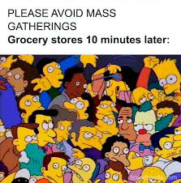
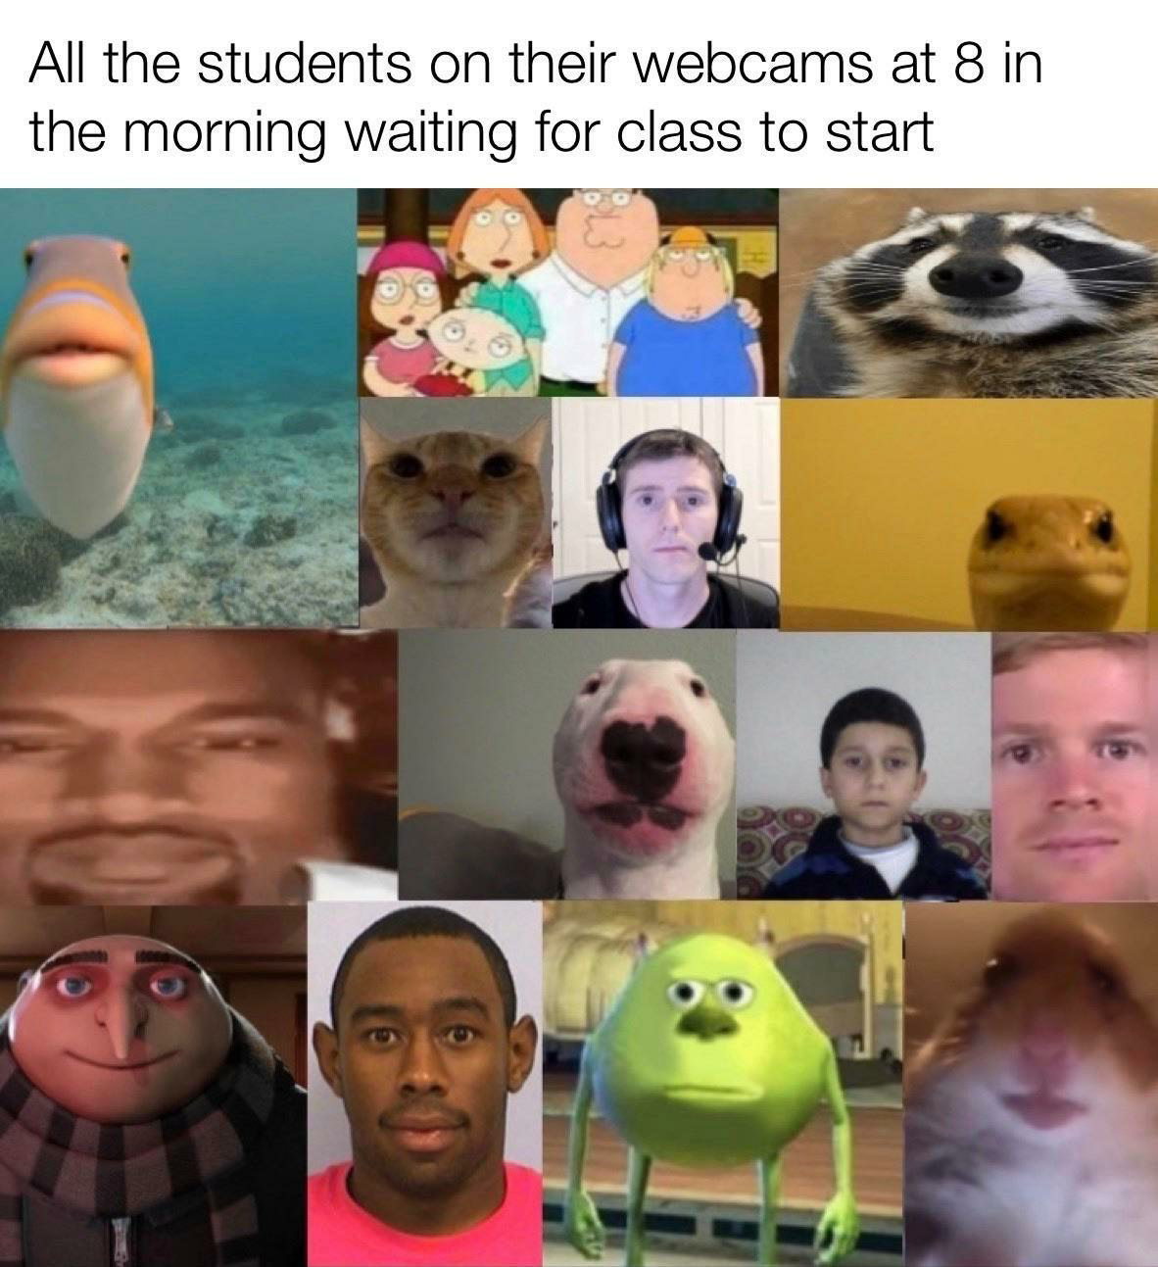

Haiku

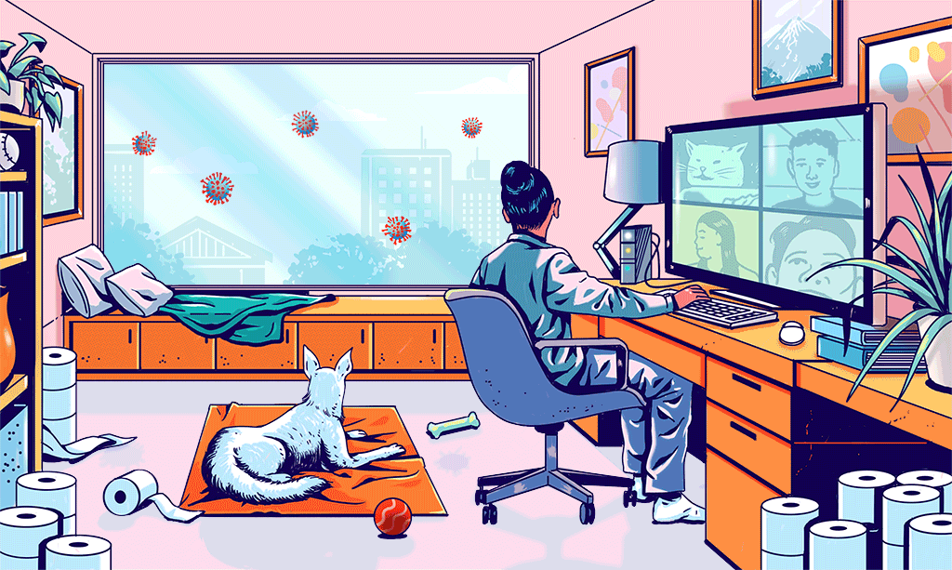

More Time, Bored Out of My Mind

Stuck inside a room.
Have all the time in the world,
Miss when time flew fast.

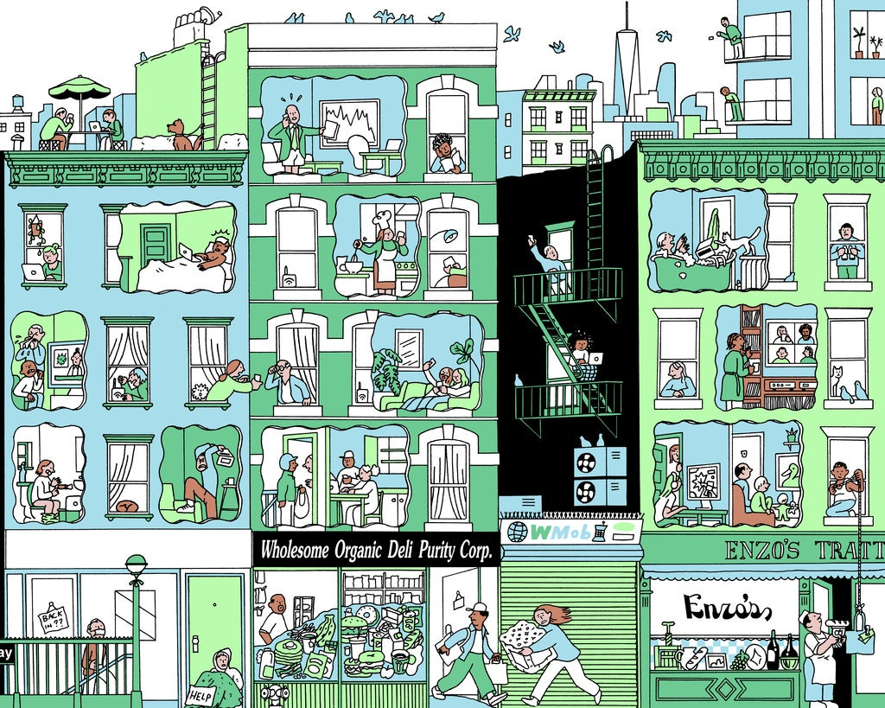

They Used to Cheep “Hi.”

(2nd Photo; Guy on rooftop with umbrella and bench)

Last view of the sky.
I will miss my time spent here.
The birds cheap “Goodbye.”
Drastic Times, Drastic Measures

(2nd Photo; Guy in the leftmost building in the bathroom)

Stocking up, those fools.
I am safe here where—uh oh.
My TP is gone.

