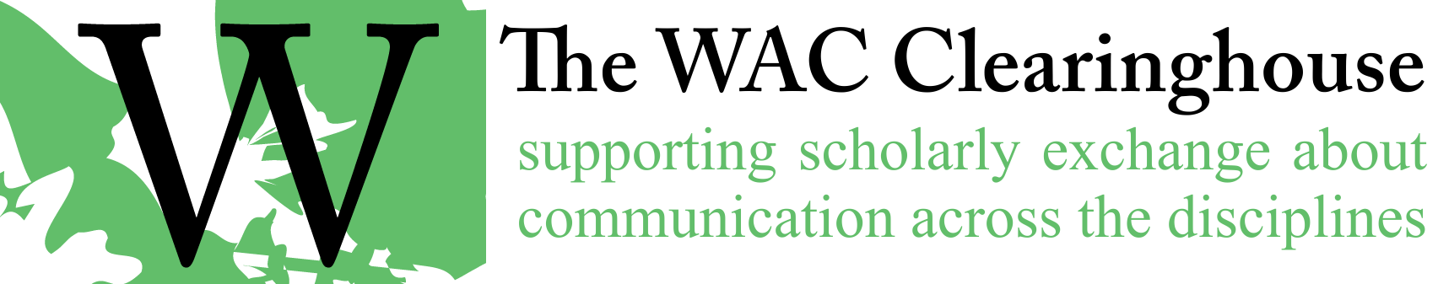

Email Template for Review of Copyedits
Hi [Author(s)/Editor(s)],

Our copyeditor has completed work on your book. The next step in the process of producing the book is your review of the edits. I’ve attached a Word document that uses tracked changes and comments. In case you are unfamiliar with track changes or use it rarely, here are some suggestions for using it well.

- Please hide changes to format (e.g., indenting a paragraph or changing a font). There are usually plenty of these changes and they’re really not relevant to our design process. You’ll find it easier to see the important changes to the manuscript if you ignore these changes. To do so, open the “Review” ribbon in a recent version of Word, look for the tracking panel, and click on “Show Markup.” You’ll see an option to hide formatting (usually a check next to the word formatting).
- Please turn off “Track Changes” in the document. This way, any changes you make to the document won’t be tracked and it will produce a cleaner document. At this point, we don’t need to see what you’ve accepted or rejected, added or removed. We simply want to get a clean document back from you – one you’re happy with.
- Please respond to all changes by accepting or rejecting them. We assume two things about these changes. First, it might be the case that the copyeditor has found a mistake or noted an issue that you might want to address (e.g., a missing citation or a request to clarify something). If you agree with the change, accept it or address the issue. Second, it might be that the copyeditor has made a judgment that you don’t want to accept. In that case, please reject the change. You can accept or reject changes by right clicking on the change and choosing accept or reject.
- Once you’ve responded to a comment, please delete it.
- Once you’ve completed your review of the document and are happy with it, please click on the “Accept All Changes” option in the Changes panel of the Review toolbar. This will accept all of the formatting changes and there will no longer be any tracked changes in the document. It will, at this point, be ready for the next step in the production process.

[Additional notes from the copyeditor and/or queries, concerns that have come up.]

Here’s an important note: Please keep in mind that this is the last point at which you will be able to make substantive changes to the manuscript. Once you return your approved manuscript to me and we move into the production stage, changes related to style and clarity shouldn’t occur. From that point on, we’ll be interested in ensuring that no errors have survived the copyediting process. Of course, I recognize that things can change, so this is a rule that can be broken. But it’s a rule that should be broken only rarely. Please make sure you pay particular attention to the manuscript at this point. It will be the last opportunity you have to strengthen your argument and ensure that you’ve been as clear as you can be.
And please, as always, pay special attention to references (both in text and in references lists). I spot checked the manuscript and didn’t see many problems, but this is a common area where oddities can work their way in.
[Include the following only if they haven’t returned the CIP data and/or marketing information form.] Finally, in case you haven’t filled it out yet, I’ve attached a copy of our information form. I’ve also attached a file that I will use for the Library of Congress Data (and another file that shows how to fill it out). This information will help us prepare the Library of Congress Cataloguing in Process information and can help market the book. The sooner it is submitted (which I’ll do as soon as I have the final manuscript from you), the sooner we can move into print. Finally, I’ve attached an updated copy (with some recent minor changes) of our style guide.
Should you need any clarifications about style issues or conventions used by the Clearinghouse, I’ve also attached our style guide. Please refer to it if you have any questions. If the guide doesn’t provide an answer, please get in touch with me or [name of series editor(s)].
When you’ve completed your review, please send the file back to me. We’ll begin the process of designing the book at that point. In a few weeks (perhaps longer, depending on schedules), you’ll see a page proof for your book.
Congratulations on all of your progress on the book. I’m looking forward to moving on to the next step in the production process.
All the best,

