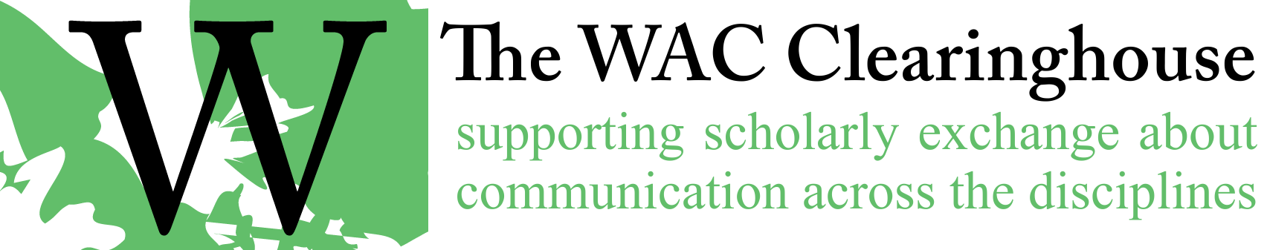

Email Template for Review of Page Proofs and Web Page
For Edited books

Hi [Author(s)/Editor(s)],
Thanks for your work on the page proofs. I’ve incorporated them and I’ve put a copy of the book on the web for you to review. You’ll find it at https://wac.colostate.edu/books/perspectives/assessment. It’s in pretty good shape, but you’re almost certain to find things to change before we announce the book. At this point, I’d like you to ask your contributors to take a look at the book. When you do so, please let them know that we won’t make any changes to correct anything other than egregious errors (i.e., no changes because of minor stylistic infelicities, no additions of yet another endnote, and no updated source citations). I will, of course, correct errors.
If you would collect the corrections and send them to me, that would be very helpful. As soon as I have the corrections, I’ll create the ePub, announce the book on the lists, and send it off for print production
A key issue at this point is ensuring that your authors do not announce the book’s availability. We want to wait to do that until we have the final book on the Web. With the large number of contributors you have in this book, you might find that difficult to avoid, but I hope that we can attempt to do so nonetheless.
Here’s a message you might send to your contributors. I know you’ve already given them a heads up, but this might be useful.
Dear Authors,
Our book is now available on the Web for you to review your chapters. PLEASE do not announce this book to your friends or on the lists or anywhere as it is still undergoing a few changes in preparation for print production. You can find the book at https://wac.colostate.edu/books/perspectives/assessment/
You may download your chapter/s and develop a list of such edits as typos and institutional affiliations. [Because we are in the late stages of publication, the publisher wants to preserve its integrity, so we don’t want to make changes of substance beyond what might occur in one line.] Let us know if there is anything of concern to you.
Send your edits to the PDF file of your chapter to me by no later than DATE and TIME. Any changes that come in after that cannot be guaranteed for print copy of the book and may not make it into the Web version either.
Thanks for all of your work on the book so far. I’m looking forward to announcing it.
All the best,

For Authored Books

Hi [Author(s)/Editor(s)],
I’ve put a copy of the book on the web for you to review. You’ll find it at https://wac.colostate.edu/books/perspectives/assessment/. It’s in pretty good shape, but you’re almost certain to find things to change before we go to press. At this point, we won’t make any changes to correct anything other than egregious errors (i.e., no changes because of minor stylistic infelicities, no additions of yet another endnote, and no updated source citations). I will, of course, correct errors.

A key issue at this point is ensuring that you do not announce the book’s availability. We want to wait to do that until we have the final book on the web and available in print.

Thanks for all of your work on the book so far. I’m looking forward to announcing it.

All the best,

