Notes for Creating ePubs
Preparing Hyperlinks
- Be sure that all of the URLs in the parent document are active before you have saved the ePub InDesign file. Open the Hyperlinks panel in InDesign, then search for http and see if each link is live. If not, create it in the panel by selecting the URL (excluding any end of paragraph markers) and clicking on the create hyperlink from URL button at the bottom of the panel (it should be the second item and will look like a page icon).
Style Changes
- Create a new style that will allow splitting in the front matter (call it Front Matter Heading).
- Go to the Paragraph Styles box, click on the quick arrow (on the right side of the dialogue box), and choose Edit All Export Tags. Then select the split document option for chapter titles, section titles, and any front matter styles (e.g., Front Matter: Front Matter Header, Front Matter: Series Title, Front Matter: Dedication) you want to use.
- Set the keep options in styles as follows:
  - In the Body Text: Figure Captions style. Keep with Previous.
  - In Body Text: Table Title style. Keep with the next five lines.
  - In the Headings (A, B, and C) styles. Keep with the next two lines.
- If you are using a book from the International Exchanges or #writing series, remove the Drop Cap options. Add a tab at 6p0.
Table of Contents
- Create a new TOC Style (do not load a previous style, even from the same series, since it might overwrite some changes you’ve made to the document styles).
  - Typically, just rename and edit the existing WAC Clearinghouse TOC style from the PDF/print version of the book. Name the TOC style WAC Clearinghouse ePub TOC.
  - Set the Title of the TOC to Contents and set the style to Headings – Front Matter Heading. Use the Standard TOC styles for the book you’re using, but remove the page numbers.
  - Make sure you set the options as shown below:
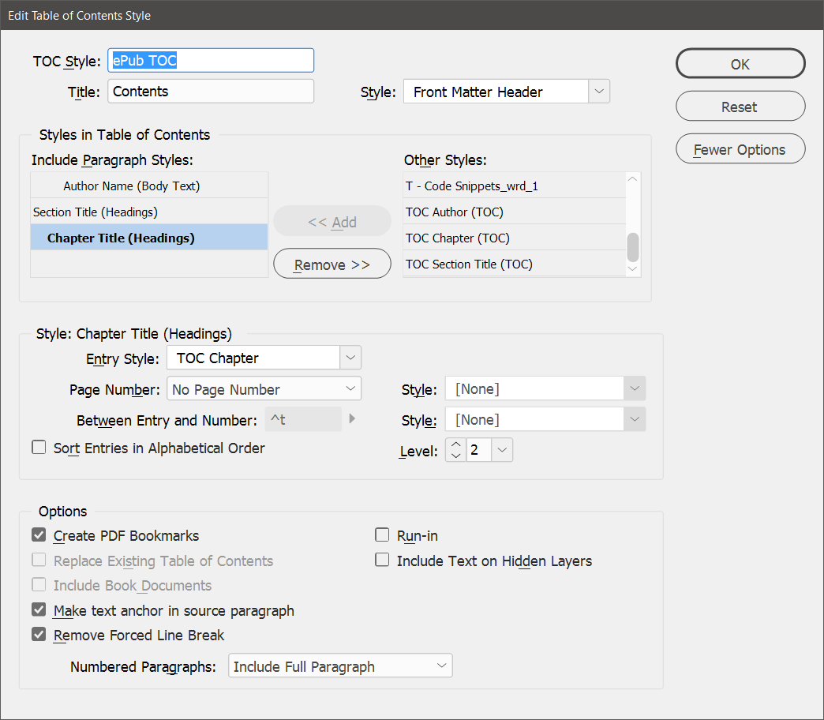

Note that it might be necessary to change the tabs and left/first line indents to make the TOC display reasonable well.

- Remove any font-size changes from the chapter titles (mostly for the Perspectives series). Search for specific font sizes and clear overrides.
- For the #writing series, change the tab location in the Chapter Title heading to 1p6.
- If you are using ePub 2.01, generate the TOC. You might need to change the tab settings in the TOC styles that you are using (e.g., as in the #writing series books) so that hanging indents work.
- If you are using ePub 3, delete the existing TOC (and the pages it was on). It will be generated at the end of the document.
- If the author names are centered, change them to flush left. You might want to make them italic.
Layout Issues
- Create a new font page. Add the cover image and have it cover the full width of the text box on a standard page.
- Delete the original front page.
- Move the original third page (title, authors/editors, and publishers) to the second position, before the series page.
- Remove indents from Chapter Title, Author Name, and Author Affiliation styles (older books).
- Delete all of the master spreads except Master blank.
- Make some changes to the Publication Information page (where the Library of Congress Info appears):
  - Add Publication Information to the top of the page and style it as Front Matter: Front Matter Heading.
  - Remove the note in the Pub Info page regarding printing on acid-free paper.
  - Change Printed in the United States to Produced in the United States.
- Remove all page breaks. Replace with end of paragraph marks that use the body text style. Then check for empty paragraphs that are styles as Section Titles or Chapter Titles. These will add blank pages to the book.
- If any figures, photos, or tables are not set in the flow of the text, change them to anchored objects in the flow of the text. The default paste options should work. If not, then use the first option (inline or above the line) and set the Y offset to the first increment (usually .0625 inches or 0p6 points)
- Remove any DOI identifiers for chapters or other book parts. These show at the bottom of pages in the PDF, but they move when the book is reformatted for ePub format and are not needed in the ePub. (These will not disappear when you remove the master pages; we break them out as independent text boxes when we edit them.)
- Remove all tracking changes introduced to control print layout. You can simplify this by selecting all text and setting the tracking to 0. Or you can use Find / Replace looking for tracking of -5, -10, +5, and +10 and changing them to 0. You’ll still have some to change, but it will take care of most of it. To show tracking and kerning, go to Preference / Composition and find the checkbox that will turn it on. You’ll see light green for tracking that is part of a style (and thus something you want to keep) and dark green for manual changes to tracking.
- Don’t worry about page numbers or headers. They don’t transfer.
- If you have footnotes or endnotes, use the options in the next section to show them as popups, if you are using the ePub 3 standard. Otherwise, have them show at the end of the section (for ePub 2.01). If you use ePub 2.01, be sure to remove any section breaks in the document. Then re-add them at the beginning of each chapter. This will allow footnotes and endnotes to have the correct numbering.
Export Settings
- For ePub 3, rasterize the (new) front page, which contains the cover image. This will keep it from being placed at the end of the document (and why InDesign places it there is beyond me).
- Specify the WAC Clearinghouse ePub TOC Style in the ePub creation dialogue box (first page). Be sure you’ve loaded it from a previous ePub InDesign file.
- On the Advanced tab, change the Split Document setting from “Do Not Split” to “Based on Paragraph Style Export Tags” (top of the dialogue box) and specify the TOC style you created earlier.
- For ePub 3, change footnote placement to Popups. For ePub 2.01, put footnotes at the end of the section.
- Map bullets to unordered lists.
- Map numbered lists to ordered lists.
- Include the epub.css stylesheet (found in the Books folder)
- On the Advanced tab, add metadata:
  - Identifier: Leave as the default provided by InDesign
  - Title: Book Title
  - Creator: Book author(s) or editor(s)
  - Date: Current Date
  - Description: Add the following info from the web page.
    - Author(s) or Editor(s)
    - Copyeditor and book designer(s)
    - Back cover copy/description
    - About the author(s)/editor(s)
    - Publication Info (citation on the web page)
    - Pub dates for print and epub/pdf editions.
  - Publisher: The WAC Clearinghouse and University Press of Colorado (or just the Clearinghouse, depending on the series)
  - Rights: Here’s a sample to model off: Copyright © 2015 Theresa Lillis, Kathy Harrington, Mary R. Lea, and Sally Mitchell. This work is licensed under a Creative Commons Attribution-Noncommercial-No Derivative Works 4.0 United States License. 440 pages, with notes, illustrations, and bibliographies. Available in print format direct from University Press of Colorado online, or at any online or brick-and-mortar bookstore. Available in digital formats for no charge on this page at the WAC Clearinghouse. You may view this book. You may print personal copies of this book. You may link to its webpage. You may not reproduce this book on another website.
  - Subject: Some keywords

