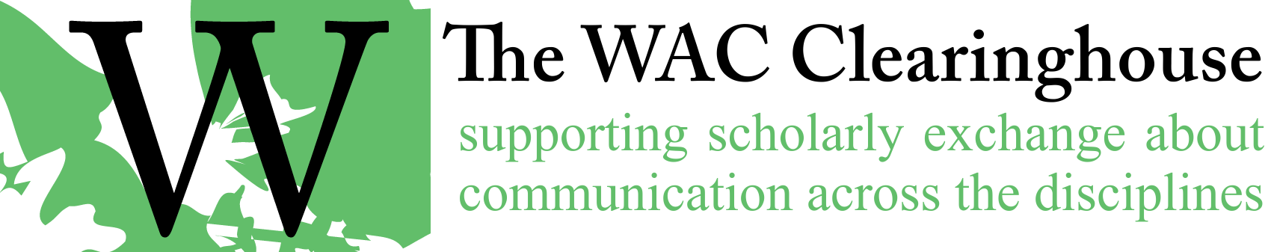

Citing Student Writing and Requesting Student Permission
The most recent CCCC statement on citing student writing can be found in the CCCC position statement, Guidelines for the Ethical Conduct of Research in Composition Studies, available at http://cccc.ncte.org/cccc/resources/positions/ethicalconduct. The following excerpt focuses on obtaining informed consent for the use of student writing:
Obtaining Informed Consent
When asking people to volunteer to participate in (or in the case of co-researchers or novice researchers, collaborate in the design and execution of) a study, we provide participants a copy of the consent document and explain the study in a way that enables the participants to understand the following points:
- The purpose of the research and its possible benefits.
- Why the participant was recruited.
- What the participant will be asked to do and how long it will take.
- What we plan to do with the information or data obtained from participants.
- Any potential discomforts, harms, or risks one might incur as a result of participating and how we plan on minimizing any potential discomforts, harms, or risks.
- Any potential benefits (separate from compensation, if any) participants may experience from the study.
- Whether or not we intend to include data in research reports that would render participants identifiable. (We always honor participants’ requests that disseminated reports contain no personally identifiable information, including data that would make them identifiable to persons familiar with the research site. We acknowledge that sometimes a conflict may emerge when some participants want to remain anonymous and others want to be recognized, and we resolve the issue before presenting, publishing, or reporting on the study.)
- How confidential data will be stored and who will have access to confidential data and materials, particularly in the case of research teams/co-researchers. If data and materials are to be included in an archive, we receive explicit consent (see “Conducting Studies Involving Archival Work”).
In addition, we emphasize the following points:
- Participation is completely voluntary.
- Participants can decline to answer any questions instead of withdrawing from the study.
- Participation is an ongoing and constantly negotiated process between the participants and the researcher or research team.
- If anonymity for participants is not possible, then we are explicit about this constraint.
- Participants may withdraw at any time without penalty or loss of benefits to which they are otherwise entitled.
For studies involving vulnerable populations who have parents or legal guardians, we obtain written permission from the parents or legal guardians in addition to the assent of the prospective participant or we seek permission from IRBs for a waiver of consent. If required, we also gain the permission of sponsoring institutions, such as public schools or private workplaces. We are careful to determine that whatever terms of access we agree to are consistent with the stipulations of applicable IRB regulations and the provisions of these guidelines.
We always provide those invited to participate in a study an opportunity to ask questions. When asked questions by participants during or after a study, we reply in a timely manner.
In the case of classes in which undergraduate and graduate students are collaborators in research projects, we guide their work toward best practices and acknowledge their collaboration in any presentation, publication, or report.
These guidelines concerning informed consent are intended to complement (not replace) any additional requirements of applicable policies, regulations, and laws.

The WAC Clearinghouse requires that authors request permission to reprint student writing in all cases. When the students are minors (under the age of 18), permission must be obtained from the student’s parent or guardian and the student must also assent to use of the writing. For the purposes of requesting permission to reprint the work of minors, we suggest you use the template on the next page. When the students are 18 or older, you may use the permission request form included in Appendix A, or you may use the Minor release form after removing “Parent or Guardian” next to the signature prompt.
Minor Student Release for Art/Writing
I hereby grant permission to reproduce and publish the artwork/writing of my child / children (name[s]) in educational publications, and any promotional materials related to them, published or copyrighted by the WAC Clearinghouse, its successors and assigns. I understand that the artwork/writing may be published in any form or format that the publisher may desire. This agreement constitutes the entire understanding of the parties relating to its subject matter and is irrevocable.
______________________________________________
Signature (Parent or Guardian) Date
______________________________________________
Printed Name
______________________________________________
Address

Description of Art or Writing:
_______________________________________________________________________
_______________________________________________________________________

